

**MAKING**

**PROPERTY**

**WORK**

**SHW.CO.UK**

**Rent | On application RETAIL / LEISURE OPPORTUNITY 23 May 2023**

An indicative view of Brighton’s Black Rock rejuvenation scheme

|  |
| --- |
|  |

## location

There are few locations more breath-taking than this one! The Black Rock area of Brighton seafront sits directly beneath the Regency architecture of the Kemptown Estate. The “Reading Room” originally served as a place for the wealthy to take the sea air. The regeneration of the area is well underway with a new 100 metre boardwalk along the Black Rock beach now open, with plans for a new outdoor play and sports area, new transport link and improved public realm gaining traction. Festivals and outdoor events will soon be visiting the event space to be created on the old Black Rock site. The Reading Room is perfectly situated to become the new place to be. Undisturbed beach views opposite the Volks Heritage Railway and a short walk from Brighton Marina.

## Description

The Reading Room is currently being restored to meet all conservation requirements with a contemporary twist. Services include three phase electricity, water supply and telecom. The Reading Rooms benefit from a two-tiered outdoor terrace area facing the beach which offers a rare opportunity to create a brand-new seafront destination all year round. The future occupier will be an operator with creative flair and imagination, able to create an exciting offer with daytime and night-time appeal. The client is seeking a place maker who is keen to build a new premier location for locals and visitors alike. They will offer a business model that will respect the important heritage and location but offer a sustainable and uplifting new location that is distinct and appealing for everyone from beach goers to evening clientele. This is a unique opportunity, and the client is willing to wait for the right business partner in order to ensure the property provides the right business for the area.

**HERITAGE**

This grade II listed building was originally designed by William Kendall, the architect responsible for Madeira Drive and the Esplanade. It previously acted as a shelter with sea views when Lewes Crescent and Sussex Square were built in the 1820s.

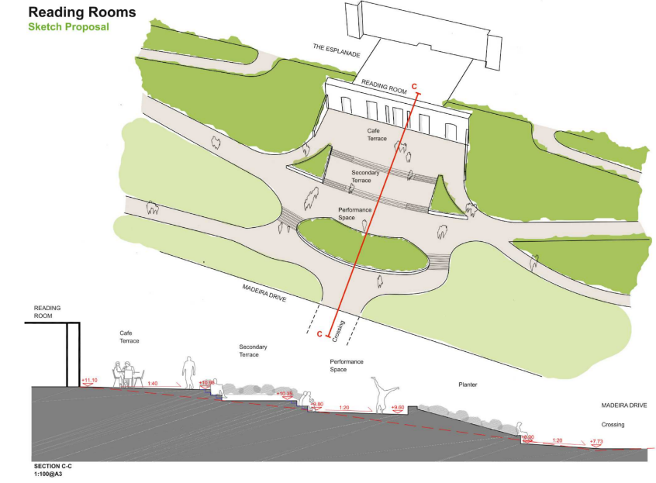

## accommodation

The property has the following approximate dimensions and area:

|  |  |  |
| --- | --- | --- |
| **Ground Floor Retail** | | |
| Main Room | 86m2 | 925 sq ft |
| West Room | 9m2 | 97 sq ft |
| East Room | 9m2 | 97 sq ft |
| Total | 104m2 | 1119 sq ft |
| **Terrace** | | |
| Terrace | 252m2 | 2712 sq ft |

## tenure

A new full repairing and insuring lease is available with terms to be agreed. Rent on application.

## legal costs

Each party is to be responsible for their own legal fees

## Viewing

For further information please contact Stiles Harold Williams Partnership LLP for the attention of Alex Denning or Richard Pyne.

Artist’s impression of the Reading Rooms. The blue line outlines the demised terrace space, the red line outlines potential additional space which may be granted under BHCC Patio Licence Scheme.

## see useful Links

See below link for a video overview of the site progress thus far:

<https://roseconsulting.sharepoint.com/:v:/s/Rose-General/ESJUHRu0y9pIgmMpxbdvB3QBlFeyKFr87eGClhClOTlnvQ?e=UcrcBD>

See below link for Blackrock Rejuvenation:

<https://www.brighton-hove.gov.uk/black-rock-rejuvenation>

See below link to Brighton and Hove City Council food standards which incoming tenants must comply with: <https://www.brighton-hove.gov.uk/brighton-hove-city-council-good-food-standards>

