King’s School Admissions Policy – September 2021

This policy was amended following statutory consultation.

This admissions policy reinforces the educational vision upon which King’s School has been established. The school will be inclusive, will meet the individual needs of all learners and will be based on the tenets and beliefs of the Church of England. It will, through its admissions, promote understanding among students of all mainstream Christian churches.

All references to ‘the school’ and ‘the main entrance to the school’ refer to the West Blatchington permanent site for the school.

Published Admission Number (PAN)
The agreed admissions number for Year 7 of the school will be 165 for 2021. That number of places will be offered in Year 7 annually.

Special Educational Needs
The admission and review of students with an EHCP or a statement of special educational needs is dealt with by a completely separate procedure involving parents, schools, the LA and a range of professionals. This procedure is integral to the making and maintaining of a compliant EHCP (or statement) by the student’s home Local Authority. Details of this separate procedure are set out in the Special Educational Needs Code of Practice.

Oversubscription criteria
Where the number of applications for admission is greater than the number of places available for any given intake, and after the agreed admission of any children with an Education, Health and Care Plan, the following over-subscription criteria will be applied in the priority order set out below:

1. Looked-after children or children who were previously looked-after, including those that have been adopted or been subject to a residence or guardianship order.

2. Children for whom it is essential to be admitted to this school because of special circumstances to do with significant medical or social needs evidenced by written professional advice from a doctor, social worker or other health professional, explaining why these needs can realistically only be met by King's.

3. Children who, on the date of admission, will have a sibling on the roll of the school. Sibling means a full, step, half, adopted or fostered brother or sister, but not cousin, who will be living permanently with them at the same address at the date of their entry to the school; the school may require proof of relationship. The exception to this is the siblings from the school’s Founding Year: siblings of the founding Year 7 will be given sibling priority regardless of where they live.

4. Children (by which is meant full, step, half, adopted, or fostered children who will be living permanently at the same address of the member of staff at the date of their entry to the school) of staff directly employed by King’s School for two years or more before the admission
application and still employed, without having given notice or been given notice that the
employment will end, at the time the offer is made.

5. This is an Ecumenical Christian School and if oversubscribed, up to 50% of the places available after the application of 1, 2, 3 and 4 above, will be based on a ‘faith’ criterion; this criterion is detailed in the notes at the end of this policy.

If more applications meeting the faith criterion are received than there are places available, then:-
i. 30% of places will be offered in order of distance from the home address of the applicant to the school, distance being measured in a straight line from the middle of the front door of the student’s accommodation to the centre of the main entrance of the school; priority being given to those who live closest to the school.

ii. 70% of places will be offered in order of distance from the home address of the applicant to the mid-point of the junction between New Church Road and Richardson Road; (the grid reference of this point being 527665:104983), distance being measured in a straight line from the middle of the front door of the student’s accommodation to the point detailed. Priority will be given to those who live closest to the node.
iii. For applicants from the same block of flats, or who live the same distance from the school, random selection by the drawing of lots will be used as a final tie-breaker.

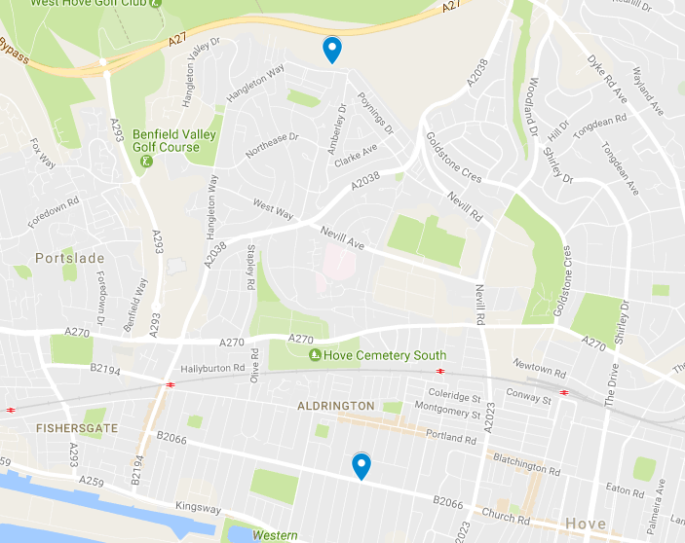

6. Other or non-faith places (referred to as ‘open’ places)
If fewer than the designated number places are taken up by those satisfying the faith criterion, then these remaining places will be added to those offered to ‘non-faith’ applicants.
The places remaining after the ‘faith’ places have been allocated will be offered to any other applicants. If there are more applicants than there are places available in this category then:-
i. 30% of places will be offered in order of distance from the home address of the applicant to the school, distance being measured in a straight line from the middle of the front door of the student’s accommodation to the centre of the main entrance of the school; priority being given to those who live closest to the school.

ii. 70% of places will be offered in order of distance from the home address of the applicant to the mid-point of the junction between Richardson Road and New Church Road; (the grid reference of this point being 527665:104983) distance being measured in a straight line from the middle of the front door of the student’s accommodation to the point detailed. Priority will be given to those who live closest to the node.

iii. For applicants from the same block of flats, or who live the same distance from the school, random selection by the drawing of lots will be used as a final tie-breaker.

‘Tied’ applications
If two or more applications cannot be separated by the criteria set out above then the place or places will be decided by the drawing of lots carried out by someone independent of the school.

Notes

Operation of waiting lists
Where in any year, the school receives more applications for places than there are places available, a waiting list will operate for at least the first year. This will be maintained by the school and it will be open to any parent to ask for his or her child's name to be placed on the waiting list following an unsuccessful application. A child's position on the waiting list will be determined solely in accordance with the oversubscription criteria set (as applicable). Where places become vacant they will be allocated to children on the waiting list in accordance with the oversubscription criteria.

The parents of students on the waiting list will be contacted twice a year to ensure that they wish to remain on the waiting list.

Home Address
The home address is where the child spends the majority of time and is living with the person who has parental responsibility and is the parent as defined in Section 576 of the Education Act 1996 (we may require documentary evidence). If a child regularly lives at more than one address, the Governing Body will have to reach a conclusion about which should be counted as the main address when allocating places. This will normally be the address where the child is registered with a doctor.

Faith Criterion
Regular attendance is defined as fortnightly attendance at a Church, which is a member
of Churches Together in Britain and Ireland or a member of the Evangelical Alliance, for at least two years* at the closing date for submission of a supplementary application form, which is midday on 30th November 2020. A Minister, Priest or Church Leader will need to sign the supplementary information form, confirming the attendance and the form must be submitted to the school before this date. A supplementary information form is available for applications under this criterion.

*In the event that during the period specified for attendance at worship the church has been closed for public worship and has not provided alternative premises for that worship, the requirements of these admissions arrangements in relation to attendance will only apply to the period when the church or alternative premises have been available for public worship.

Appeals
Parents who fail to gain a place at King’s School for their child can appeal to an Independent Appeals Panel.

Sixth Form

Sixth Form Overview & Entrance Requirements
King’s Sixth Form will be based on the tenets and beliefs of the Church of England. It will, through its admissions, promote understanding among students of all mainstream Christian churches, whilst supporting students to become young adults equipped with the confidence and qualifications they require to make the most of the opportunities available to them when they leave school.
King’s will give priority to applications from internal students who have attended Year 11 of the school during the preceding academic year.
King’s will also accept applications for entry to the Sixth Form from external students. The Published Admission Number for external students for entry to Year 12 in September 2021 will be 50, but more places may be available subject to the take up by internal students.
Acceptance onto a programme of subjects/courses is dependent upon a student having achieved the necessary minimum entry and course requirements, as published in the prospectus and course guide. Individual subjects may be limited in the number of students they can accommodate.

Application Process
All application forms should be completed and submitted by the midday on the last Friday of the February Holiday.
External students must meet the same academic minimum entry and course requirements as internal students.
Where there are more applications than places available to external students, the ‘Oversubscription Criteria’ will apply.

Oversubscription Criteria for External Students
Should applications from suitably qualified external students (i.e. those meeting the minimum entry and course requirements) exceed the number of places available to external students, the Oversubscription Criteria (Criteria 1-6) as set out on pages 1 and 2 of this admissions policy will be applied to those applications in the given order e.g. criteria 1, 2, 3, 4, 5i), 5ii) then 6.
The Supplementary Information Form referred to in criterion 5) (Faith Criterion) should be completed by the Priest/Minister and returned to the school as described in criterion 5) save for the deadline will be the same deadline as given for the Sixth Form Application Form, which is midday on the last Friday of the February Holiday.

