

**Physical Distancing -   
Principles and blue print**

The following principles demonstrate how physical distancing can be achieved in BHCC workplaces. There may be specific issues for each building which will need to be looked at individually.   
  
Risk Assessments can be arranged with your Health & Safety business partner.

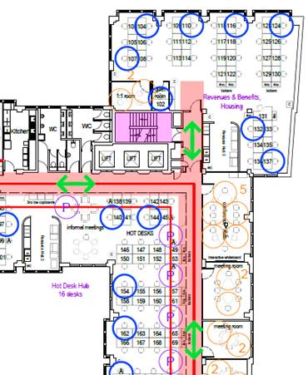

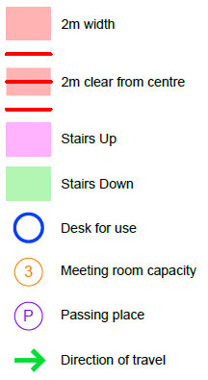

You should measure the width of your corridors. Where a corridor is wider than 2m, two-way travel is safe.

 You should also measure 2m from the centre of any walkways. Any desks or shared resources within this boundary must not be used.



Where possible and safe, stairwells should be a single direction to help reduce the risk of coming into close contact with colleagues. Stairs should be clearly signed as up or down.

Where it is not possible to have single direction stairs (e.g. if there is only one stairwell in a building) then these can be two-directional. Passing points should be identified to minimise the risk of close contact.

Blue circle indicates a desk available to use physically distancing. These should be positioned furthest away from walkways and facing in the same direction where possible. If you imagine a 2m diameter circle around each desk, these circles should not overlap.



Users will need to file into and out of the room to maintain 2m. The first person to enter should sit at the furthest seat and be the last to leave. Meeting rooms should have signs on them indicating the maximum capacity based on the 2m rule.



Passing places can be set up where there are two-directional walkways. These should be clearly signed.



Tape and signage should be used to indicate the direction of travel around an office.

# **Smaller offices**

The same principles apply as with open plan offices. If staff cannot maintain 2m distancing then the priority should be to reduce the number of people in the office until that is possible.

If this is not possible (e.g. it is an essential service that can only be delivered from this location) additional measures must be put in place to reduce the risk of infection. Other measures may include repositioning furniture so that staff so not face each other, installing protective panels between areas where close contact is unavoidable, and making additional PPE available for staff and visitors.

It is important that a workplace risk assessment is carried out for all council Workplaces. While this risk assessment is completed by the Corporate Landlord for the council’s main buildings, it is up to the Site Responsible Person at smaller satellite offices and workplaces to arrange for this risk assessment to be completed with support from their H&S business partner.

# **Other Notes**

**Doors** – any doors that are not fire doors or do not have viewing panels in them should be held open This is to avoid having to touch door handles unnecessarily, and to help staff see along corridors and into offices.

**Lifts** – one person only, and prioritise people with mobility issues.

**Entrance/Exit** – It is expected that staff will have to sign in and out, so a single entrance & exit is required wherever possible.

**Fire Evacuation** – In the event of a fire evacuation or drill all stairs and walkways revert back to emergency exit stairs and exits.

**Kitchens** – Depending on the size of the facility, only one person may be able to use a kitchen at any time. 2m distancing should be in place and any shared equipment (e.g. microwaves and fridges) should be wiped clean by staff after each use.

**Toilets** – Depending on the size of the facility, only one person may be able to use a toilet at any time.

**Resource Hubs** - Depending on the size of the facility, only one person may be able to use a resource at any time. 2m distancing should be in place and any shared equipment (e.g. printers and stationary) should be wiped clean by staff after each use.

**Corporate Hotdesks** – these should either be made unavailable or assigned to a specific team where there is demand. This will reduce the risk of infection associated with shared equipment.