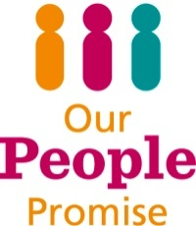

A Guide to Individual Performance Management

Important: This guidance should be read in conjunction with the following:

- Guidance for Managers during Covid-19
- Making the most of your PDP during Covid-19

Introduction

I believe that success in any organisation is achieved not just by ‘what we do’ but also ‘how we do it’.

I want us all to continue to build our confidence and competence and be proud of what we’ve achieved and how we achieved it. I expect all staff to be focused on delivering our priorities, while behaving in a way that defines us as a highly regarded public service that people want to work for and with.

Our behaviour framework provides us with a common language for how we go about our daily work alongside our PDP objectives that describe what we do; helping us to manage and improve our performance to build a better, more effective organisation with better outcomes for our customers and stakeholders.

The framework applies to all of us no matter what general or specialist skills our job requires. It is a tool to help us and will enable us to identify the behaviours we need to do our job to the highest standard, but also to recognise and feel comfortable addressing behaviours that don’t.

Part of our people promise to you is that we will offer you opportunities to do your best, and be a great place to work so that we can do our best for the city. You and your manager will use your PDP and performance reviews to help you do well in your current job, and also allow you to identify what you could do to progress into a new role, should you want to.

I hope you will experience the benefits of focusing our efforts not just on what we do, but how we do it.

Kind regards,

Geoff Raw
Chief Executive

Managing People’s Performance
Managing the performance of our people is just one element of how we measure the performance of the whole organisation. There are 7 other elements in our Performance Management Framework.
Alot happens before we get to setting our own personal objectives. All of the following plans are written, reviewed and signed off:
- Corporate Plan (Our Plan)
- Directorate Plans
- Service/Team Plans
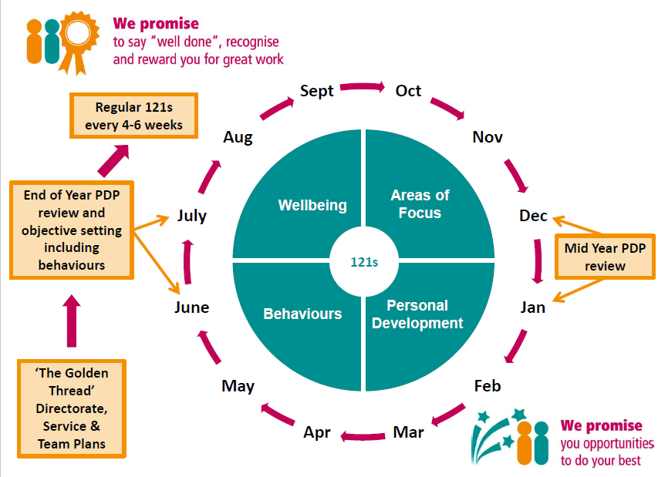

We time our individual performance reviews to fall in line with the timetable for these plans being signed off:
- End of Year reflection on our individual performance and objective setting for the coming year – June/July
- Mid-Year review – December/January
Your objectives therefore help to achieve the objectives in your Team, Service and Directorate plans as well as the Corporate Plan (Our Plan).
(Besides this there may be other objectives for you in your particular role).
Our Plan 2020 – 2023
There are three areas of change that a huge number of citizens told the Council they want to see in the City and they are:
- Making our city carbon neutral by 2030
- Improving access to good quality housing and reduce homelessness and rough sleeping
- Building community wealth so that local people and organisations benefit from prosperity in the city
These should therefore form part of your 121 and PDP conversations. During 2020 the focus will be on how we can help achieve ‘making our city carbon neutral’. The 121 and PDP templates have been updated to help you have these conversations.
The way we do things – Our Behaviour Framework
Our behaviour framework helps us to measure how well we are doing this. We all have one core objective that is the same – to “Role model the values and behaviours of the council.”
Incorporated into this objective is the delivery of our Fair and Inclusive Action Plan, Let’s Talk About Race campaign and pledge to be an anti-racist council.
The behaviour framework was created with 200 staff members across different services, roles and grades who shared with us what they would see and hear if colleagues were role modelling our values of Respect, Collaboration, Customer Focus, Creativity, Efficiency and Openness.
After being in place for a while and listening to lots of feedback, we have simplified it to make it clearer and easier to work with.
The PDP and 121 templates
We designed our PDP and 121 templates to make them easy to use without having to read a lot of information first.
The most important thing about 121s and performance reviews is actually having the conversation, not the filling in of forms. The forms are there to guide the conversation and ensure you cover what we consider are essential areas. You can of course tailor the forms to meet the needs of your team if necessary.
If you need a little extra guidance, there are some step by step instructions for mid-year and end of year reviews, and guidance on how to use the spidergram with the behaviour framework.

Use the hyperlinks below to take you to the right section:
End of the year review, start of the new year – June/July
Mid year review – October/November
Using the spidergram
End of the year review, start of the new year – June/July
At the end of year review, you will recording your reflections on performance on the current PDP form, and starting a new one to record the objectives, development needs and any aspirations for the coming year.
- Make sure you have your end of year review meeting booked in with your manager.

- Look at your current work objectives and personal development objectives and take some time to make some notes on what you have done to achieve them on your current PDP form.

Examples and any feedback you’ve received will help you put together the evidence for this.

- Get a new, blank PDP, and write a summary of how you think you’ve performed in the past year. (Part 1 of the PDP form)

- For 2019/2020 end of year reviews there is a new section Part 2 of the PDP form - Covid-19 Pandemic – Response to the crisis.

There is also some additional guidance for managers and staff to support you in having PDPs during Covid-19.

Please refer to that guidance for further support.

- Start thinking about what your new objectives will be for the year ahead. You may need to carry over some existing ones.

On the new PDP form write your suggested new objectives and any existing ones you think should be carried over, ready for the meeting. (Part 3 of the PDP form)

(There is e-learning available on setting SMART objectives on the Learning Gateway)

- Look at the behaviour framework and use the spidergram to reflect on how well you are role modelling the behaviours.
Use it to note down your two areas of strength and two development areas on the new PDP form. (Part 3 of the PDP form)
This can then be compared to any previously completed ones to see any improvements and identify any new development areas.
Think about what you can do to support the delivery of the Fair and Inclusive Action Plan and pledge to be an anti-racist council. (See Appendix 1)
- Consider any other development needs you might have or any new career aspirations and make a note of them on the new PDP form ready for the meeting. (Part 4 of the PDP form)

- Have a look at the Apprenticeship qualifications available and, if you’re interested, make a note on the new PDP form to disuss with your manager. (Part 5 of the PDP form)

- Take your current and new PDP forms to the meeting:
You and your manager can then discuss and agree:
  - Your performance in the past year.
  - What progress you have made towards achieving your personal and development objectives.
  - What your new objectives should be.
  - The completed spidergrams and any changes there have been since the last time.
  - Any new behaviour strengths or development areas.
  - Any new personal development objectives or aspirations.

- After the meeting, make any agreed changes to both PDP forms (old and new) and send copies to your manager.

- In your regular 121s continue to revisit the PDP form to make sure your Areas of Focus are right.

You can agree with your manager at any point that your objectives need to change
and your PDP form can be updated.

Back to the beginning

Mid-year review – December/Jan
At the mid-year review, on your current PDP form, you will be recording the progress you have made on your objectives, adjusting or adding any new objetives, and adding in any new development needs or aspirations.
- Make sure you have your mid year review meeting booked in with your manager.
- Have a think about what you/tour team have done to help achieve Our Plan 2020 – 2023 pritorities and make some notes.
(Part 2 of the PDP form)

- Look at the objectives and personal development objectives on your current PDP form that you agreed in June/July. They may have changed since then but that’s ok.

Take some time to make some notes on what you have done towards each objective in the ‘mid/year’ box provided. Examples and any feedback you’ve received will help you with the evidence.

  - Are the objectives still relevant? Do they need to change? Do you need any new ones?

  - If your answer is yes, note down some suggestions you would like to discuss with your manager.

- Consider any new development needs you might have or any new development/career aspirations, and make a note of them ready for your PDP meeting. (Part 4 of the PDP form)

- You may want to complete a new spidergram and ask your manager to do the same to see what might have changed and identify any new development areas.

- Have a look at the Apprenticeship qualifications available and, if you’re interested, make a note on the PDP form to disuss with your manager. (Part 5 of the PDP form)

- Take the PDP form along to your mid year review meeting. You and your manager can then discuss and agree:

  - What progress you have made towards achieving your personal and development objectives.
  - Any changes needed to your objectives.
  - The completed spider grams and what changes there have been since the last time.
  - Any new behaviour strengths or development areas.
  - Any new personal development objectives or aspirations.

- In your regular 121s continue to revisit the PDP form to make sure your Areas of Focus are right.
You can agree with your manager at any point that your objectives need to change and your PDP form can then be updated.

Back to the beginning

Using the spidergram
Why should I use the spidergram?
The spidergram has been created to allow you and your manager to reflect on how well you are role modelling the behaviours in our framework.
Once completed, it creates a really useful and interesting conversation between you and your manager. You’ll be able to discuss what behaviours you are strong at, behaviours that you could work on to improve, as well as exploring why there might be a difference between yours and your manager’s results.
It’s a really good way to understand how others see us and how we might support others and develop or improve certain behaviours.
Ideally scores given should be evidence-based and supported by examples from you, your manager and other colleagues.
The most important part of the exercise is the conversation you have and the plan you put in place with your manager.
How do I use it?
Have a look at the behaviour framework summary. There are example behaviours for each of our 6 Values and there are 2 Management and Leadership sets of behaviours; 8 sets of behaviours in total.
The aim is to score each of the 8 behaviour sets; how much are you role modelling the behaviours?
If you want to, you can score every example behaviour and then average your scores, or you can look at the examples and give yourself an overall score for that set of behaviours.
For example, if you feel that you ‘always’ role model the behaviours that demonstrate our value of Respect then you’d score that a 6 and so on.
0 – no opportunity to observe (not for yourself of course!)
1 – never
2 - rarely
3 – sometimes
4 – often
5 – frequently
6 - always

Do I have to score all of the sets of behaviours?
Staff members You should score the 6 behaviour sets for our Values.
Managers and Leaders You should score all 8 sets including the Management & Leadership ones.
However, we do accept that not all of the statements will necessarily be relevant to everyone. In that case agree with your manager those behaviour themes/statements that are most frequently needed in your role and rate yourself against those.
Can I ask other people to complete a spidergram for me?
You can discuss this with your manager. Between you, agree who the right people to ask for feedback would be. It is good to get a variety of people if you do choose to do this. For example peers, colleagues, customers, partners etc.
They can score you on each of the behaviours and even provide written feedback if that’s what you and your manager would find valuable.
It can all be made anonymous by posting into your locker (if you have one) or sending in the internal mail.
One of the easiest and quickest ways to get written feedback is to use Stop, Start, Continue. A template can be found at the end of this document.
Agree the people to give you feedback with your manager and then ask them to provide you with something they would like to see you stop doing, something they would like you to start doing and something they would like to see you continue doing. It can be more than one thing if you wish.
Again you should encourage them to give evidence/examples.

Back to the beginning
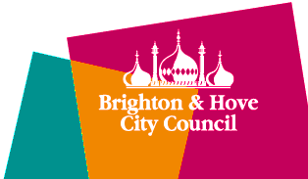

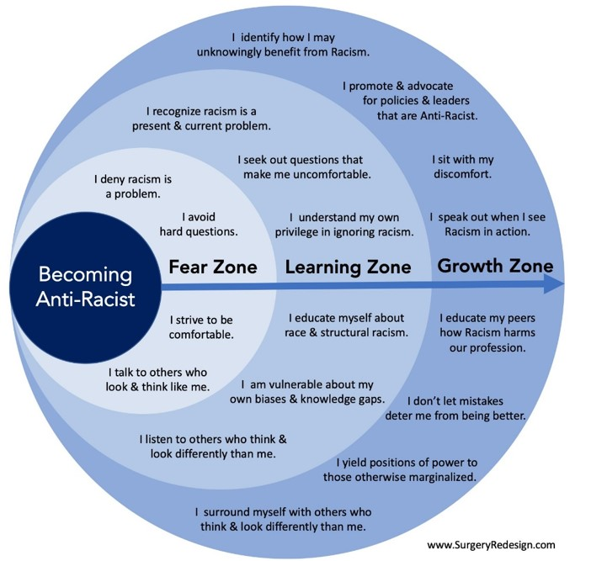
Appendix 1 – Becoming Anti-Racist
Appendix 2 - Stop, Start, Continue
Name (optional):
Behaviour set (optional)
Stop

Start

Continue

