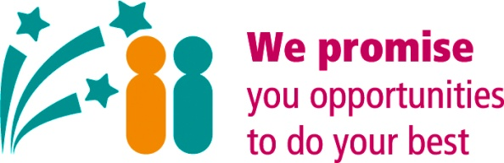
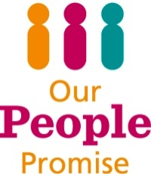

Performance and Development - 121 Template
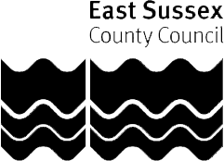
Regular 121s/Supervision should be held every 4 to 6 weeks. You can adjust this form so that it works for you making sure you retain the 4 key areas of:
- Wellbeing
- Areas of Focus
- Behaviours
- Personal Development & Aspirations
Name: |  | Date:

Part 1 - Wellbeing
How are you? Is there anything you would like to talk about? Any support you need?

There are many wellbeing resources on the Wave pages for you to refer to including the Wellness Action Plan that can help you structure the conversation and put any required actions in place.

Part 2 - Areas of Focus – What we do
2a Focus on Covid-19 – Recovery and Renewal
What are the current cirmstances? What has changed? What achievements are you proud of? Are there any challenges we need to disucss. What next?

2a Reflection:
What has gone well; what have you achieved since the last 121?

Is there anything you’ve found challenging? What did you do about that? Is there anything more to do?
(Any action points as a result of this conversation can be added to Section 2b)

2b Looking forward:

What do you need to achieve in the next 4-6 weeks? (Action Points AP)

Part 3 -
Behaviours – How we do things
You can use completed spidergrams or 360 reports to support this part of the conversation.
Are there any specific strengths or areas for development that we need to discuss in relation to the behaviour framework?

How are you contributing to the delivery of the Fair & Inclusive Action Plan?
How are you supporting our Let’s Talk About Race campaign and pledge to be an anti-racist council?

Part 4 - Personal development
Are there any immediate development needs?

Anything else? AOB

IMPORTANT: Please make sure the date of this 121 is recorded on PIER. | Date entered:

