

**Cancelling a course booking**

**Step 1:** Make sure you are logged on to the Early Years Channel

**Step 2:** From the menu bar select *‘My Profile and Bookings’*

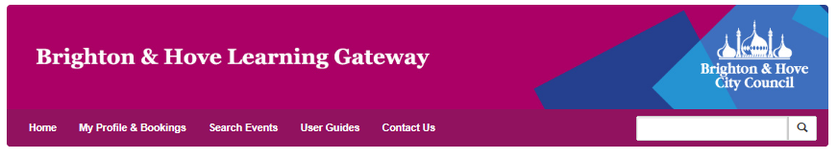

**Step 3:** Select ‘*Cancel a booking’*

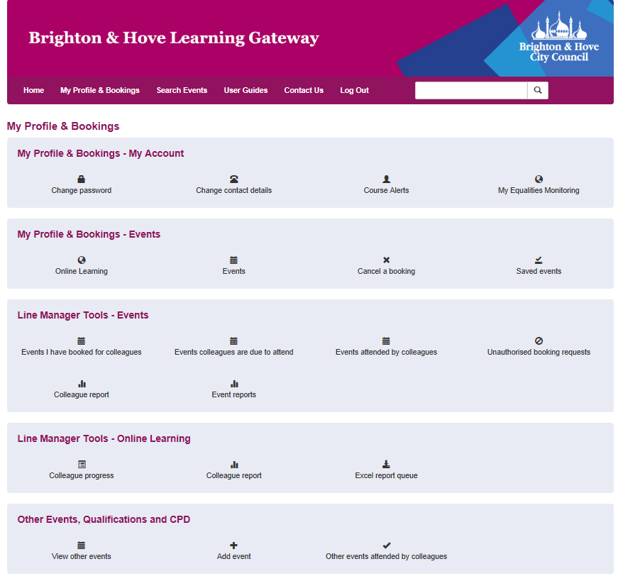

**Step 4:** From your list of bookings find the course place you wish to cancel. Select *‘Cancel booking’* from below the course details

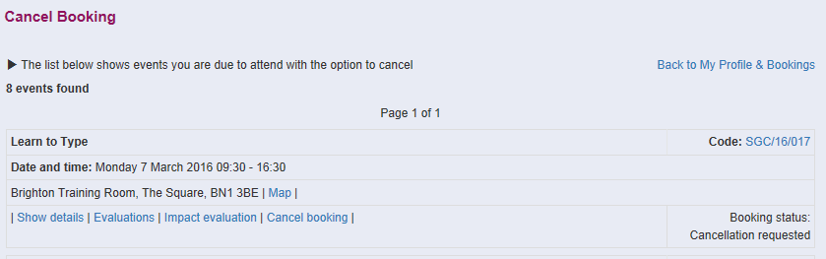

**Step 5:** Your details will be displayed along with the course details you wish to cancel. Please enter a reason for the cancellation and click you have read and agree with the cancellation policy. Press ‘Submit Query’

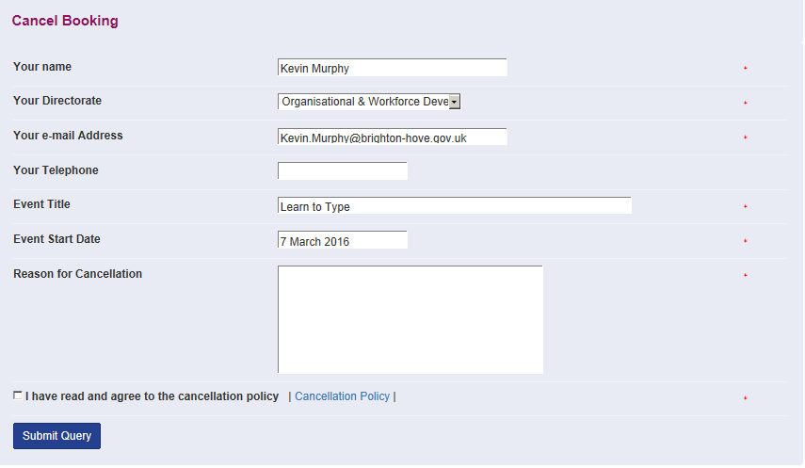

**Please note:**

You will immediately receive an email noting your request to cancel the course place.Once we have cancelled your place you will receive a final notice confirming the cancellation

**Substitution**

If you wish to make a substitution to avoid the, please contact us with details of the person that will be attending in advance of the training date. Before contacting us, please ensure the person substituting has an account on the Early Years Channel so that they will have a training record and access to their certificate following the training course.