Traffic Counter Information

Site No: 622
Site Location: Off A270 – Stanmer Park access road outside Lower Lodge

Location of counter:

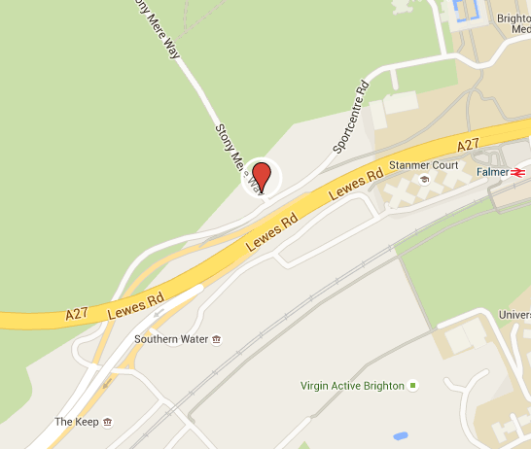

Average monthly counts for past four years:

Average yearly counts for past four years:

Information:

- All numbers represent average count of traffic per day.
- Sometimes there is not enough information to account for all missing data. Information on the procedures used for dealing with missing data can also be found on the above website.
- This site has additional historic data which can also be found in the accompanying Excel file.
- Counts represent the average flow of traffic over a 16 hour period from Monday to Friday.

