Traffic Counter Information

Site No: 509
Site Location: A23 London Road between Cedar Gardens and Leahurst Court Road

Location of counter:

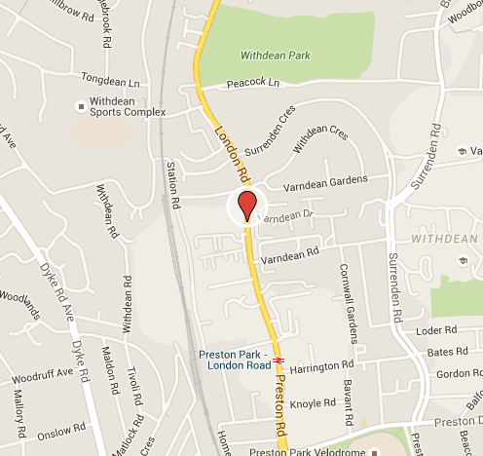

Average monthly counts for past three years:

Average yearly counts for past three years:

Information:

- Data is totalled for all directions of travel (eg both northbound and southbound).
- All numbers represent average count of traffic per day.
- Sometimes there is not enough information to account for all missing data. Information on the procedures used for dealing with missing data can also be found on the above website.
- This site has additional historic data which can also be found in the accompanying Excel file.
- Counts represent the average flow of traffic over a 16 hour period from Monday to Friday.

Vehicle Class:

Counters categorize vehicles into ten different classifications.

- More in depth classification data is available upon request (e.g. Northbound vs Southbound, monthly totals, variation x days of the week).
- Counts represent the average flow of traffic over a 16 hour period from Monday to Friday.

Vehicle Speed:

Counters categorize vehicles into 12 speed groups, and produce average speeds.

- Overall average speed

- Average speed in each direction

- Speed Classification

- Additional speed data is available upon request (speed categories by direction, average speed x days of the week)
- Counts represent the average flow of traffic over a 16 hour period from Monday to Friday.

