Nancy’s top ten Storytime titles
- 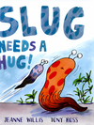
When it begins to bug slug that his mummy doesn't hug him, he leaves home to find out why. Kitten suggests he should be furrier, so he puts on a woolly hat, while Bird suggests he needs a beak. Soon, Slug has a new look, will his mummy hug him now? Willis, Jeanne/Ross, Tony
- 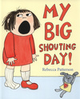
Bella is having one of those days - her biscuit is broken, she has a hurting foot and ballet is too itchy for words. All she can do is shout. But by the end of the day, when she's all tired out from being shouty, Bella knows there's one magic word and one magic mummy to make things better again. Patterson, Rebecca
- 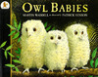
A story in which three baby owls wake up one night in their hole in a tree to find that their mother has gone. Darkness gathers and the owls grow anxious, until at last she returns and they bounce up and down with joy. Illustrated by Patrick Benson in full colour. Waddell, Martin
- 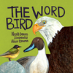
Discover the delights of nature with zoologist, poet and top children's book author, Nicola Davies. Follow her young adventurer as she treks through the jungle, dives deep down into the sea and climbs high up into the trees. 'The Word Bird' features birds of all shapes, sizes and colours. Davies, Nicola
- 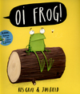
This is a tale about a frog who discovers that all animals have their special places to sit! Cats sit on mats, hares sit on chairs, mules sit on stools and gofers sit on sofas, but Frog does not want to sit on a log! Jam-packed with animals and silliness, this original story will have young children in fits of laughter. Gray, Kes
- 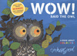
At night, when we are feeling tired and ready for bed, owls are just waking up. But this curious little owl decides to stay awake all day, instead of all night, and discovers a world bursting with colour! But when the night-time comes around again, the stars above her head are still the most beautiful of all. Hopgood, Tim
- 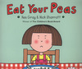
Daisy knows just what she does not want - peas! Her mum tries to bribe her with promises of puddings, new bikes, swimming pools, if only she'll eat her peas! However, Daisy stands firm and, in a clever twist, Mum and Daisy both get exactly what they want. Gray, Kes
- 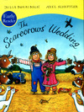
Written in Julia Donaldson's glorious rhyme and illustrated in glowing colour by Axel Scheffler, this book is a fabulous love story. Scarecrows Betty O'Barley and Harry O'Hay are planning the perfect wedding, but wicked Reginald Rake has other ideas. Harry must become a hero before he and Betty can have the wedding of their dreams. Donaldson, Julia
- 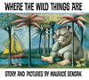
Max's night-time adventure in the land of the Wild Things is a classic of 20th century children's picture books. Sendak, Maurice

10. 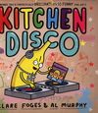
When the sun goes down, the Kitchen Disco starts up - and all the fruit in the fruit bowl come out to play. There are lemons who break-dance, tangerines who twirl and some very over-excited apples. 'Kitchen Disco' is a zany and hilarious rhyming picture book for young children. Foges, Clare

