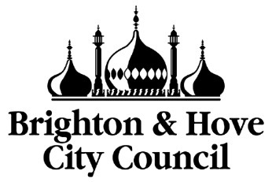
SAFER FOOD ALLERGEN WORKSHOP
ARE YOU A FOOD BUSINESS OWNER?
You may be liable if something goes wrong
To help protect you, your business and your customers Brighton & Hove City Council are holding an allergen workshop
Who is the workshop for?
This three-hour workshop is suitable for catering staff of all levels including chefs and waiting staff, as well as managers and business owners.
Expert Trainers
Brighton & Hove City Council Environmental Health & Trading Standards in partnership with Allergy UK, will provide practical training to include
- Allergen controls
- The Food Hygiene Rating Scheme
Learn how to manage food allergens in your business and find out more from the inspectors about how your business can achieve and keep that all important 5-star rating.
Don’t miss out on this opportunity to
keep you and your customers safe.
Cost : £25
Please contact Brighton & Hove Trading Standards for details on when our courses are running :
trading.standards@brighton-hove.gov.uk or Tim Curphey on 01273 292495
Venue: Brighton Town Hall

