Pharmacy – Domiciliary Smoking Cessation Referral Form

Please complete all sections highlighted in red and where possible provide additional information if known.

Patient’s Registered GP: | Patient’s Name:
GP Address: | Patient’s Address:  Postcode:  D.O.B. / /  NHS NUMBER: / /
Postcode:

Referrer Name:

Referrer Address

Patient’s Telephone No:

Mobile No:
Relevant Medical Conditions:

Is the patient housebound? Please answer | Is the patient eligible for free prescriptions? If known please answer
Signature of Referrer: | Date of Referral: / /
THE PATIENT HAS GIVEN CONSENT FOR A STOP SMOKING ADVISOR TO VISIT THEM AT HOME: Please answer.

Pharmacy use only –Please ask the patient to sign below at the beginning of the first visit.

I (PATIENT) GIVE INFORMED CONSENT TO RECEIVE SMOKING CESSATION ADVICE AND TREATMENT:

PATIENT’S SIGNATURE: DATE : / /

ANY KNOWN RISKS TO SELF OR OTHERS? If known please answer
(if yes please detail below )

ANY COMMUNICATION ISSUES (BLIND, DEAF, LANGUAGE)? If known please answer
(if yes please detail below )

ANY ACCESS ISSUES? : If known please answer  (if yes please detail below) |  | CARER’S / KEY HOLDER’S NAME:  (if known, please state)  TELEPHONE NO:
E-mail this form to your nearest Domiciliary Pharmacies Provider listed on the back
Created on 1/12/2015
Domiciliary Smoking Cessation Pharmacies for Brighton & Hove

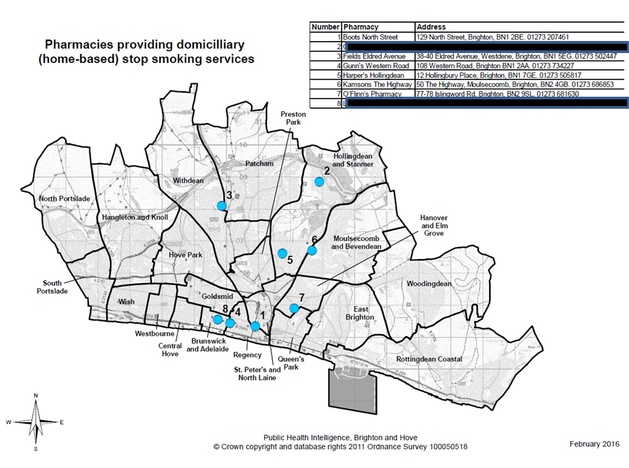

PHARMACY NAME | ADDRESS 1 | ADDRESS 2 | POSTCODE | TEL.NO | NHS EMAIL
Coldean Pharmacy | 16 Beatty Ave | Coldean | BN1 9ED | 01273 605657 | coldeanpharmacy.brighton@nhs.net
Boots Pharmacy | 129 North Street | Brighton | BN1 2BE | 01273 207461 | bootschemist.northstreet.brighton@nhs.net
O'Flinns Pharmacy | 77-78 Islingword Rd | Brighton | BN2 9SL | 01273 681630 | oflinn.pharmacy@nhs.net
Harpers Pharmacy | 12 Hollingbury PL | Brighton | BN1 7GE | 01273 505817 | harperspharmacy.brighton@nhs.net
Fields Pharmacy | 38-40 Eldred Ave | Brighton | BN1 5EG | 01273 502447 | fieldspharmacywestdene@nhs.net
Kamsons Pharmacy | 50 The Highway | Brighton | BN2 4GB | 01273 686853 | kamsonspharmacy.moulsecoomb@nhs.net

