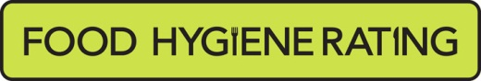  Food Hygiene Rating Scheme:  Request for a re-visit |  | 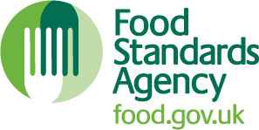

Notes for businesses:

- As the food business operator of the establishment you have a right to request a re-visit for the purposes of re-rating if you have taken action to rectify the non-compliances identified at the time of inspection.
- There is a charge of £154.00 for this re-visit. There is no limit on the number of requests you can make but the charge will be applicable each time.
- You must provide details of the improvements made with your request, including supporting evidence where appropriate.
- Once this request form is received and checked by the Food Team manager and the relevant Food Safety Officer, a Food Safety Team representative will make contact with you to take payment.
- The re-visit will be carried out within a maximum of three months following the receipt of your request and payment of the fee.
- Applications will only be accepted and deemed valid once payment has fully cleared.
- The Food Safety Officer will give you a ‘new’ food hygiene rating based on the level of compliance that is found at the time of the re-visit - you should be aware that your rating could go up, down or remain the same.
- To make a request for a revisit, please use the form below and return it using the contact details at the bottom of the form..

Business details
Food business operator/proprietor

Business name

Business addresses

Business tel. number |  | Business email

Inspection details
Date of inspection |  |  |  |  | Food hygiene rating given

Action taken
Please describe the remedial action you have taken with reference to the issues identified in the inspection letter/report provided to you by your local authority with your score:
Compliance with food hygiene and safety procedures

Compliance with structural requirements

Confidence in management/control procedures

Please provide any other supplementary evidence (e.g. photographs, invoices, copies of relevant HACCP documentation etc.).

Signature
Name in capitals

Position |  | Date
Please now return this form to: Brighton and Hove City Council, Food Safety Team, Bartholomew House, Bartholomew Square, Brighton, BN1 1JP (post) or ehl.food@brighton-hove.gov.uk (email)

