Step by Step guidance on how to register on the new EY Channel
To register a new establishment or service you need to be the service manager or delegated training lead. Any requests made by other people will not be authorised and deleted. We may contact you to authenticate your request prior to authorising your account.

The first person to register must be the line manager or the person in the establishment that will get copies of training confirmations, have access to training records and monitor bookings.

You can have more than one line manager/training lead per establishment but please note those registered as such will get all copies of training bookings and notifications from all people in the establishment.

Step 1 - The Registration Process
- To register, either select ‘register’ from the home page or for more information before registering select ‘First Time Here’

- Complete your title, first name, last name and job title.

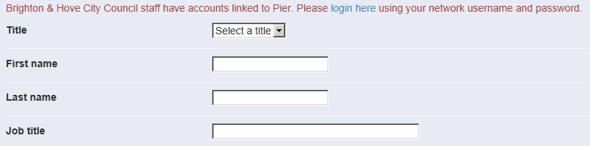

- The next stage is to tell us about where you work or register a new establishment. Select Early Years Provider from the drop down list and then a further drop down list will appear for you to select your establishment which is your place of work or team.

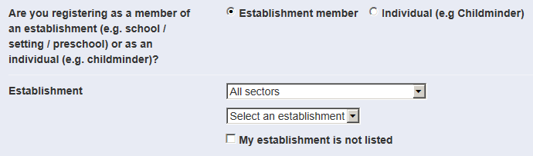

If you are not part of an establishment or team (e.g. childminder) please describe this in the job title and select ‘individual’ at this stage. This will open up fields to complete your home address and contact details. When registering as an individual you will receive confirmation of your account and you will be able to login once you have completed the registration process and your account has been authorised.

Select ‘My establishment is not listed’ if you cannot find your sector or establishment on the drop down lists.

Add your establishment details.

Please ensure you complete all details and in particular let us know details about your establishment, contact telephone number and line manager name. This is the person in your establishment or team that manages training records, bookings etc. This person will receive copies of emails from people attached to the establishment. If you are adding a new establishment it may be your name.
If you are an establishment with separate departments and different managers or need to set up a separate department, please also tell us about that.
When registering a new establishment you will receive confirmation of your account and you will be able to login once you have completed the registration process and your account has been authorised.

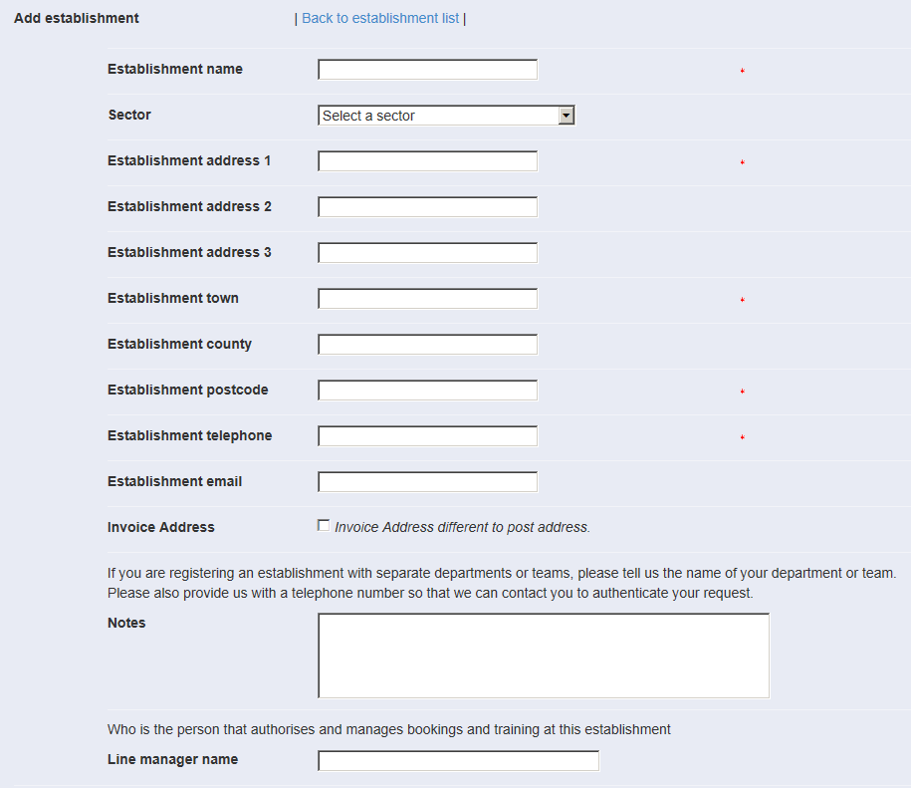

- Complete the final registration fields and set your username, which must be an email address and password
- Press submit

Step 2 – completing the equalities section

The council must consider how different people will be affected by the decisions we make and services we provide. We are required to do this by law, under the Equality Act 2010.
With up-to-date and accurate information we are able to
- better understand our service users / residents to meet their specific needs.
- Identify possible discrimination or barriers to accessing our services
- Anticipate and avoid potential difficulties for some people and work to remove them.

We will only ask that the equalities questions are completed once on the Brighton & Hove Learning Gateway on registration (or first time login if your account has been set up by your manager while booking places). There is also a ‘prefer not to say’ option for all questions.
You can find out more about equalities monitoring at the council here: http://www.brighton-hove.gov.uk/content/council-and-democracy/equality/about-you-equalities-monitoring

Step 3 Marketing

The Brighton & Hove Gateway can keep you up to date with new events as they are added.
You can select the areas and courses you are interested in hearing about or un-tick the box
if you do not want to receive course alerts from us. We do not pass on or sell your details
and you can opt out or select different options at any point through ‘My Account and
Bookings’

And finally…

- Please contact us directly if you have any problem or do not hear from us with
confirmation of your username and password
- Where establishments are approved, once you have an account set up, you are able
to start booking places on courses.

