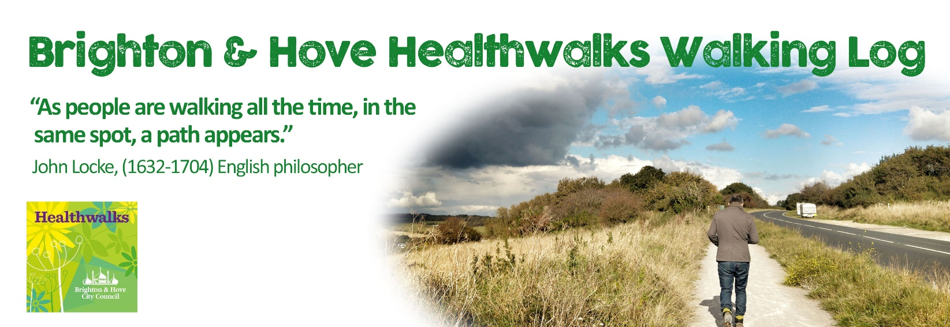
WEEK 1:
“If you're walking down the right path and you're willing to keep walking, eventually you'll make progress.” Barack Obama
 | Location | Date & Time | Steps/miles walked | Notes, thoughts, observations
Monday
Tuesday
Wednesday
Thursday
Friday
Saturday
Sunday
 | Weekly distance/step total:
WEEK 2:
“I like long walks, especialy when they are taken by people who annoy me.” Noel Coward
 | Location | Date & Time | Steps/miles walked | Notes, thoughts, observations
Monday
Tuesday
Wednesday
Thursday
Friday
Saturday
Sunday
 | Weekly distance/step total:
WEEK 3:
“All truly great thoughts are conceived while walking.” Friedrich Nietzsche
 | Location | Date & Time | Steps/miles walked | Notes, thoughts, observations
Monday
Tuesday
Wednesday
Thursday
Friday
Saturday
Sunday
 | Weekly distance/step total:
WEEK 4:
“Home is everything you can walk to.” Rebecca Solnit
 | Location | Date & Time | Steps/miles walked | Notes, thoughts, observations
Monday
Tuesday
Wednesday
Thursday
Friday
Saturday
Sunday
 | Weekly distance/step total:
WEEK 5:
“When I'm in turmoil, when I can't think, when I'm exhausted and afraid and feeling very, very alone, I go for walks. It's just one of those things I do. I walk and I walk and sooner or later something comes to me, something to make me feel less like jumping off a building.”
Jim Butcher, Storm Front
 | Location | Date & Time | Steps/miles walked | Notes, thoughts, observations
Monday
Tuesday
Wednesday
Thursday
Friday
Saturday
Sunday
 | Weekly distance/step total:
WEEK 6:
“But the beauty is in the walking -- we are betrayed by destinations.” Gwyn Thomas
 | Location | Date & Time | Steps/miles walked | Notes, thoughts, observations
Monday
Tuesday
Wednesday
Thursday
Friday
Saturday
Sunday
 | Weekly distance/step total:

