Example focus book planning
For more information contact Cbabiesafe
Phone…….

Email……..

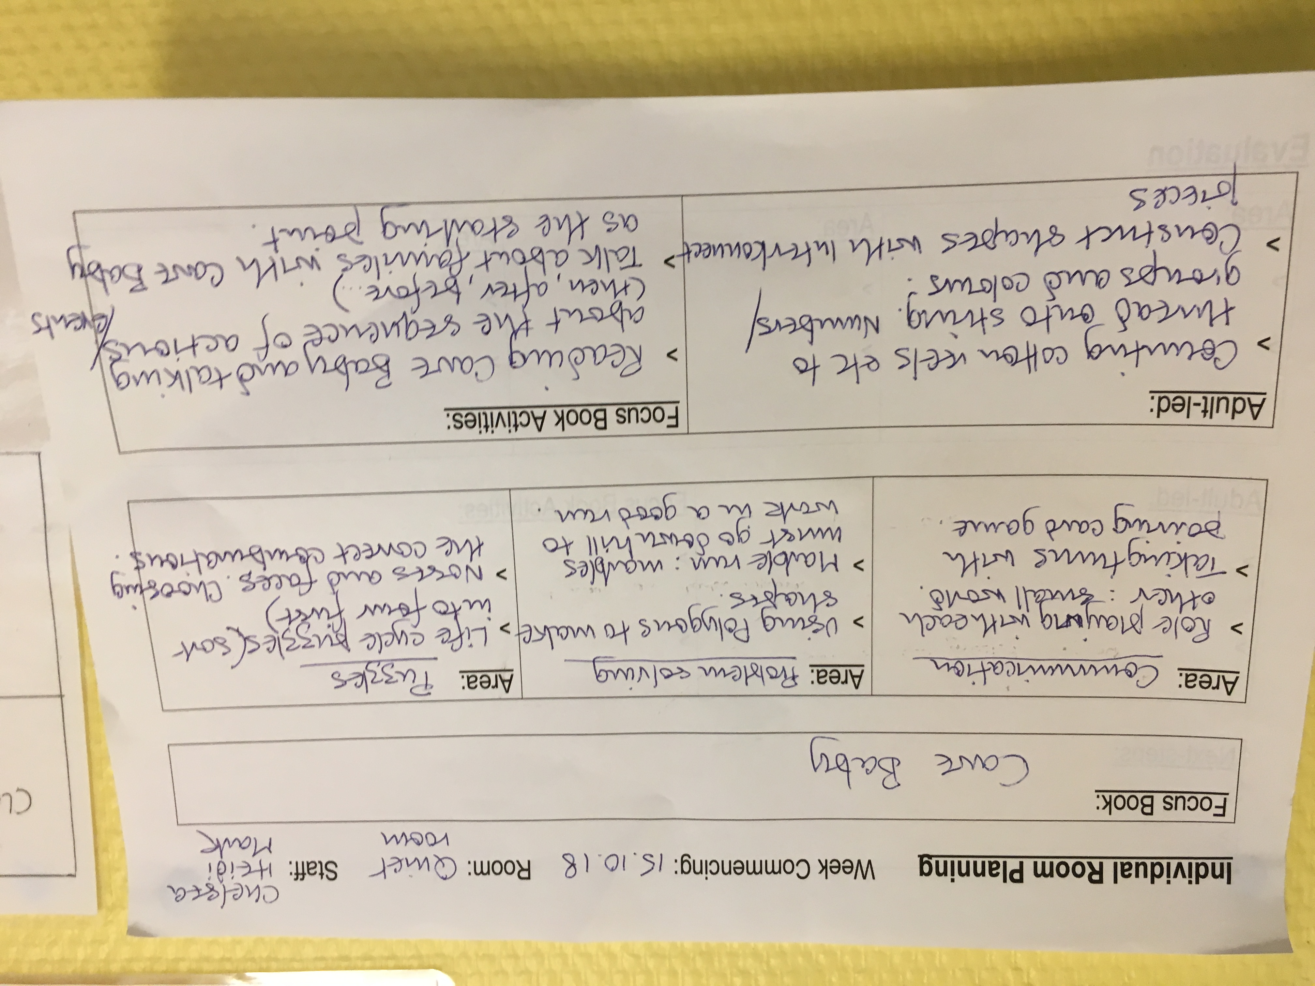

Footsteps in a full day care chain of nurseries, caring from children from birth to 5. They have three branches in Hove, Portslade and Hollingbury.

For more information contact:

Hannah Moss or Hannah Simpson on 01273 779034
footstepsdaynursery@gmail.com
Narrowing the Word Gap at
Footsteps

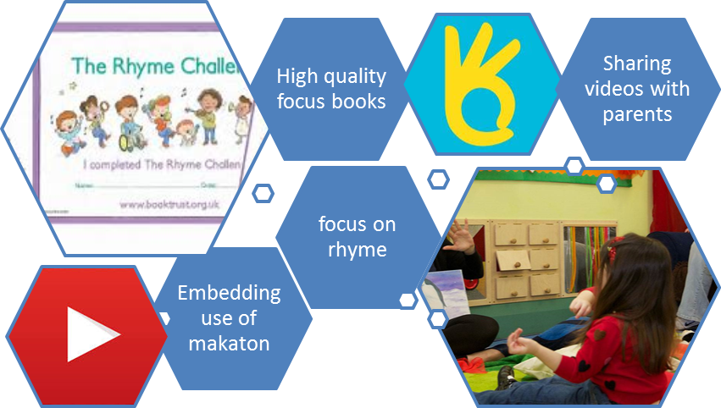

Rhyme Time Challenge in action!

Footsteps have taken up the rhyme time challenge, which they are rolling out to all three branches. There is a focus rhyme every 3 weeks with sheets being sent home to parents.

Each rhyme is accompanied by a video of a Footsteps practitioner using Makaton to tell the rhyme. These videos are shared on Facebook and on each child’s Tapestry account.
NEW IDEA
Involve parents in creating displays to document their storytelling visits

NEW IDEA
Involve parents in creating displays to document their storytelling visits

Hannah reports that these have been very successful so far, with videos being likes and shared very widely. Feedback from parents has been really positive – they report children wanting to watch the videos repeatedly over breakfast!

The whole team recently took part in a Makaton refresher course which has enthused staff and really boosted the use
of sign in the nursery.

Hannah says “the children love using Makaton and have even been asking to be taught the signs for their favourite songs. We recently learnt the signs for the Rainbow Song, and the children can recite it for themselves, it is fantastic to see!”

Focus books
NEW IDEA
Involve parents in creating displays to document their storytelling visits

NEW IDEA
Involve parents in creating displays to document their storytelling visits


The management team have begun using focus texts which are changed
on a 3 week cycle. The books are carefully chosen to include exciting high quality literature that match the various age groups and seasonal themes.


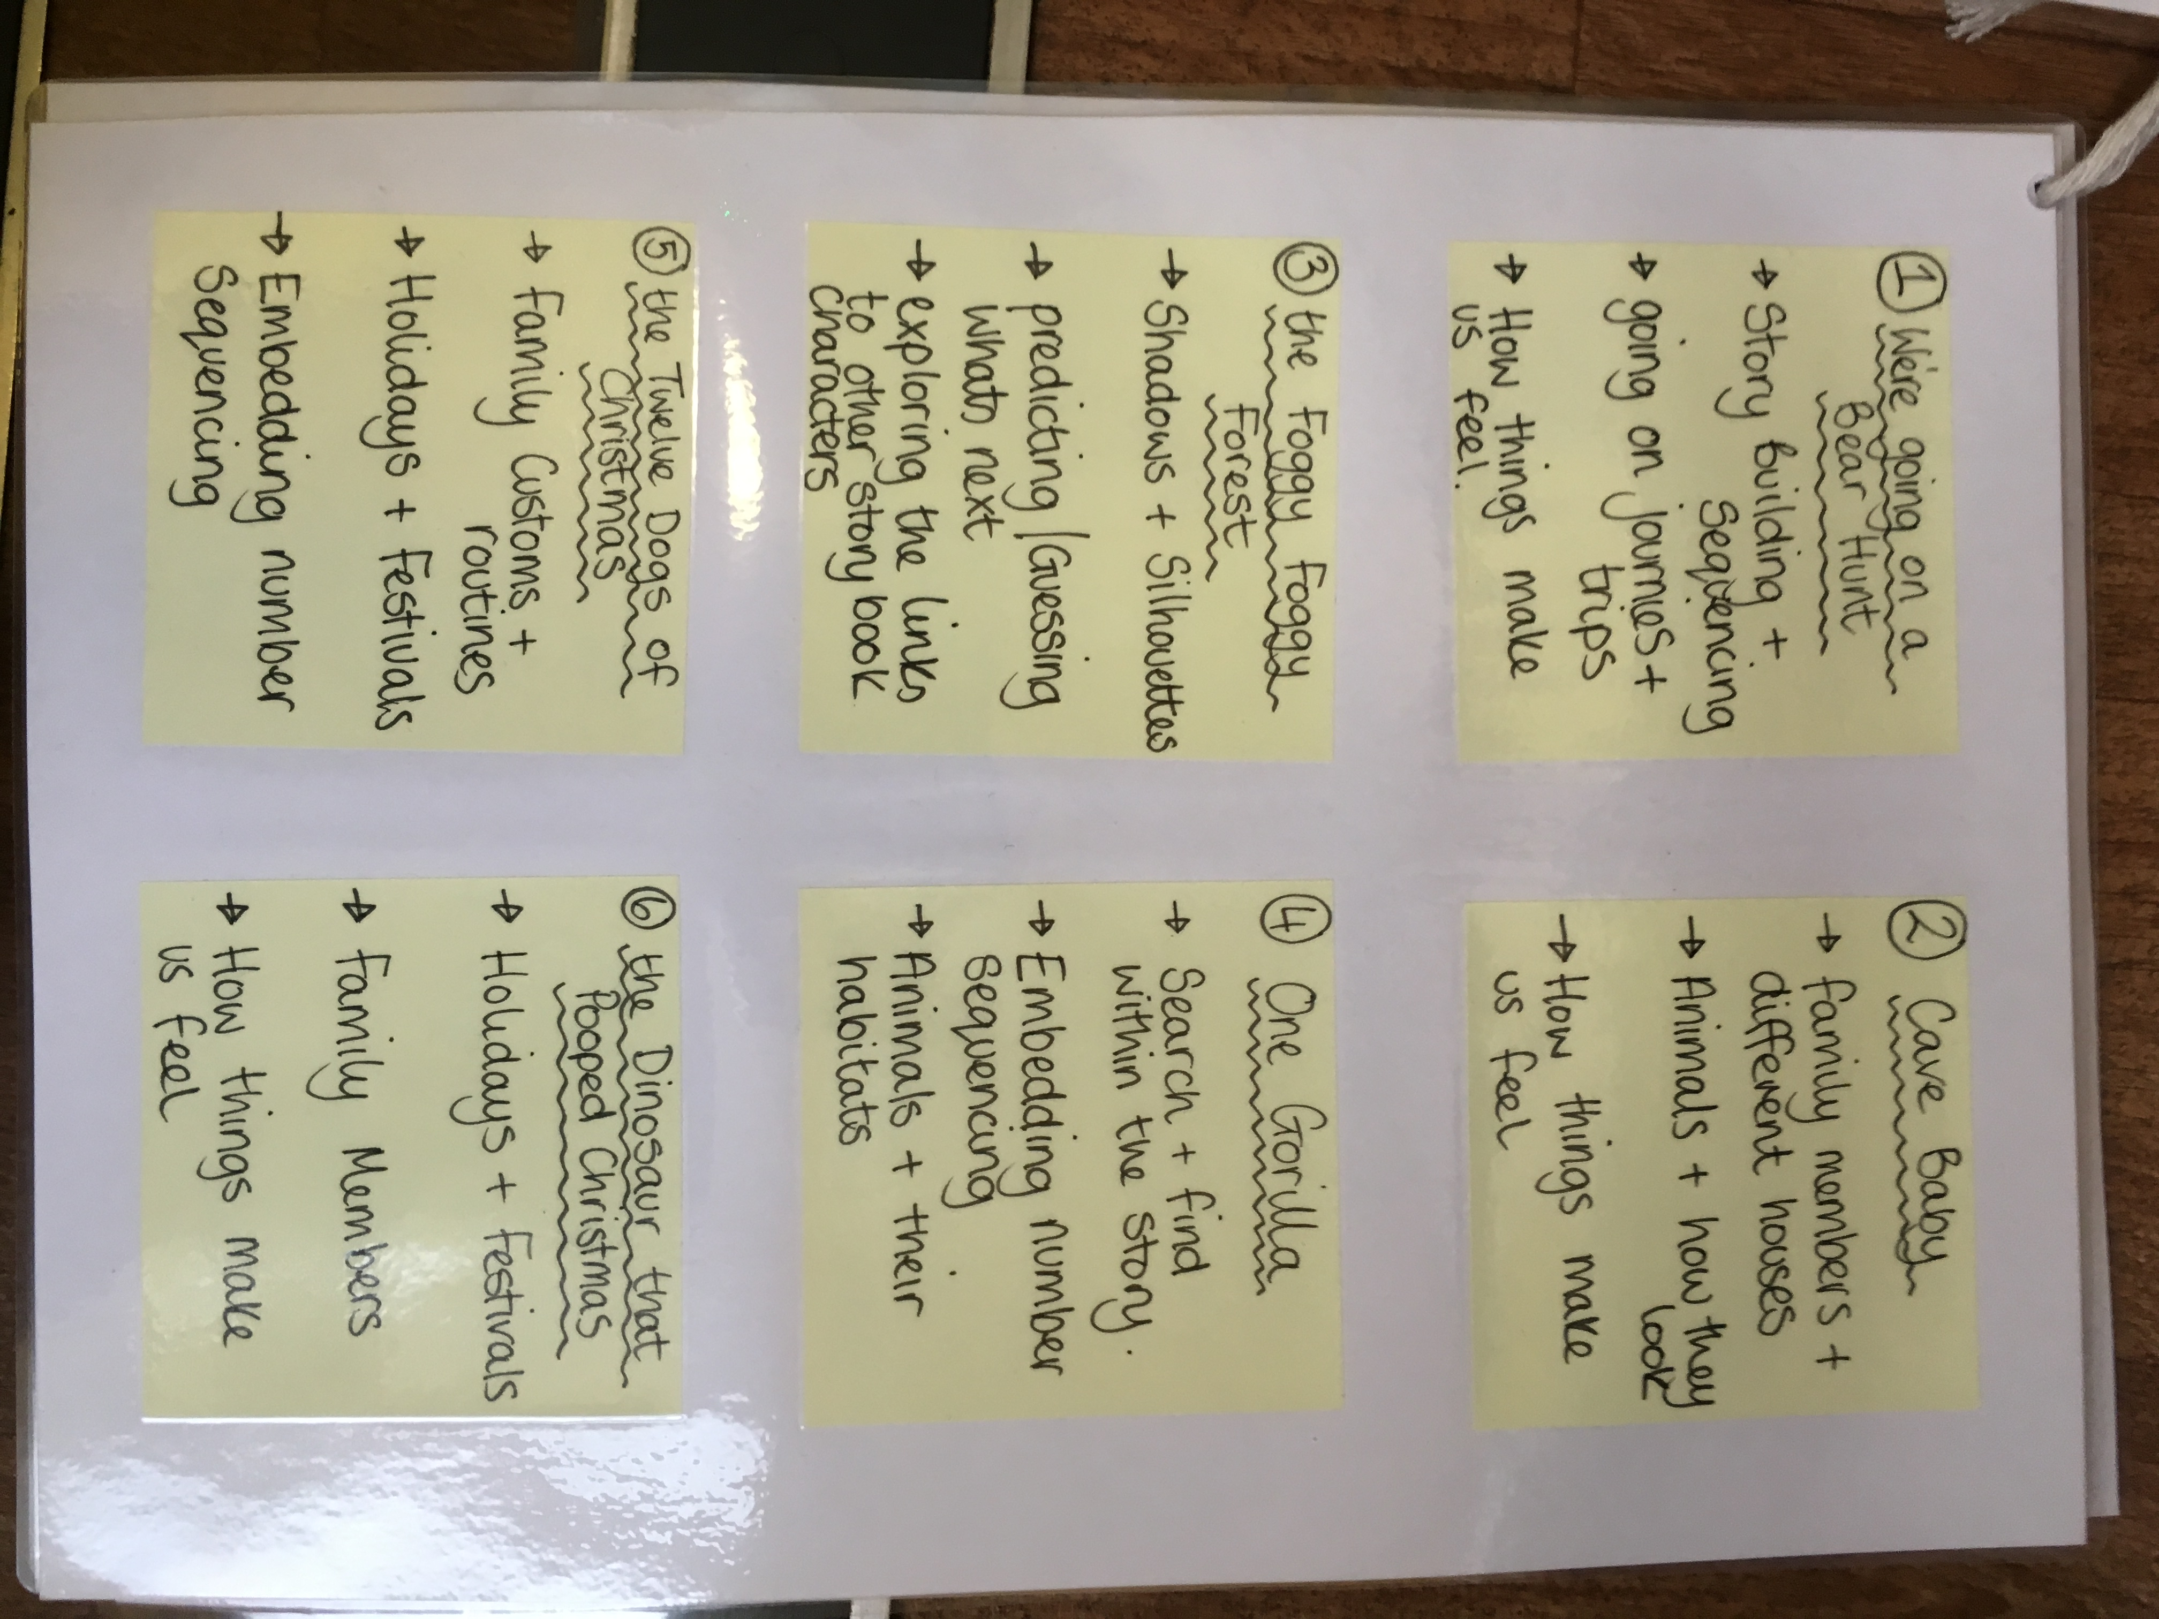
NEW IDEA
Involve parents in creating displays to document their storytelling visits

Hannah reports that this focus book planning has excited the staff as much as the children – practitioners have been instrumental in creating exciting activities around these books that tie in with their key children’s next steps and compliment their interests.

