Cycle Counter Information

Site No: 961
Site Location: Richmond Place, East of St Peters Church, North of bus stops

Location of counter:

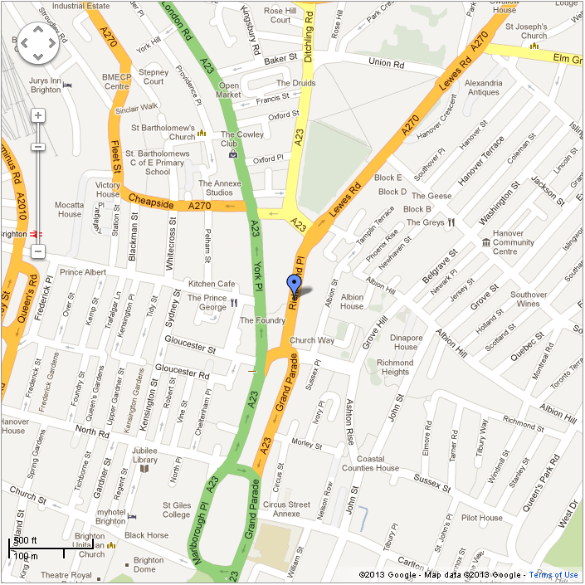

Average monthly counts for past four years:

Average yearly counts for past four years:

Information:

- Data is totalled for all directions of travel (eg both northbound and southbound).
- All numbers represent average count of cycles per day.
- Sometimes there is not enough information to account for all missing data. Information on the procedures used for dealing with missing data can also be found on the above website.
- This site has additional historic data which can also be found in the accompanying Excel file.
- Counts represent the average number of cycles over a 16 hour period from Monday to Friday.

