2
Important information from Trading Standards for Tobacco Products
From 20th May 2016 there are new laws on selling of tobacco and tobacco related products.
It is important that you keep to these laws.
There are 2 new laws - we have outlined the basic requirements below:

Tobacco and Related Products Regulations 2016 |  |  | Standardised Packaging of Tobacco Products Regulations 2015
Applies to the following products:- |  |  | Applies ONLY to the following products:-
- Cigarettes / Cigarillos  - Hand rolling tobacco & pipe tobacco  - Water-pipe tobacco (tobacco shisha)  - Blunts (tobacco leaf rolling paper)  - Smokeless tobacco (chewing / snuff)  - Novel tobacco products (e-cigarettes) |  |  | - Cigarettes  - Hand Rolling Tobacco (HRT)
This law makes the following changes: |  |  | The law makes the following changes:
Health Warnings  They must be in English  They will cover 65% of the front and back of packet  Applies to all tobacco products? |  |  | These are the plain packaging regulations. Cigarettes and hand rolling tobacco (HRT) must be in plain packaging.
Herbal Tobacco Products  - Must have the following warning:  “Smoking this product damages your health.” |  |  | Compliant Stock will have to have the following:  - No graphics, logos or colours  - Only the brand name, health warning and UK Tax stamp  - Smoking cessation number / website  - Olive / Green (Pantone 448C) colour packs.  - A minimum of pack size 20 (Cigarettes)  - A minimum pouch size of 30g (HRT)  - Standard Size of product packaging  - Restrictions on labelling of cigarette sticks.
Chewing Tobacco
- Must have the following warning:
“This tobacco product damages your health and is addictive”
Flavouring & additives in cigarettes & HRT will be banned from 20th May 2016  - Menthol cigarettes are able to be sold until May 2020– as long as they comply with other legislation (e.g. plain packaging) |  |  | 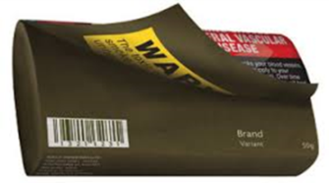  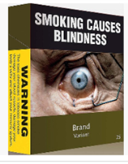  Example of Cigarettes plain packaging:-  Example of Hand rolling tobacco plain packaging:-
E-Cigarettes advertising & promotion
- Similar restrictions apply to
e-cigarettes, as already apply to tobacco products (e.g. age restriction, ban on advertising & free gift promotions, etc.)

Labelling & Ingredients  - Tar levels and other ingredient information should no longer be present on the outer packaging. |  |  | - Flavours are banned from cigarettes & HRT  - But are not banned from shisha, cigars, etc.  But these products cannot state such flavours on their label due to the new packaging rules.
All non-compliant stock must be sold by 20th May 2017
– any items found after this date may be subject to legal action.
Trading Standards
Brighton and Hove City Council
Bartholomew House
Bartholomew Square
Brighton BN1 1JE
Tel: 01273 292523 (Option 2)
Email: trading.standards@brighton-hove.gov.uk

