
Youth Service and Youth Crime Prevention Referral Process
Referral Process

The Youth Service and Crime Prevention Team (part of YOS) provide support to young people with vulnerable to complex needs. Both provide a targeted service, as shown in the diagram below. The young people we work with are more likely to move to a high level of risk if they do not receive an early intervention. They are also more likely to require longer term intervention from a multi agency team/specialist service.

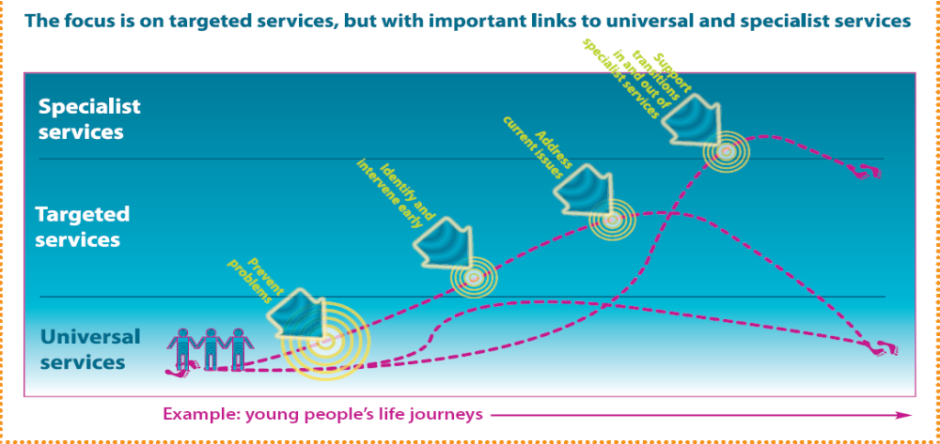

The Youth Service will work with young people to build resilience and encourage constructive use of their leisure time. We work with young people from age 13 to 19 (up to 25 with special needs).

The Youth Crime Prevention Service works with young people who are committing anti-social behaviour and are at risk of entering the criminal justice system. They work with young people from age 10 to 17.

Work is delivered with young people on a one to one basis and in targeted group work.

Both teams provide support on the following:-

- To work with young people to build confidence and self esteem
- Support young people to access universal youth provision
- To build resilience around risk taking behaviour, including alcohol, substance misuse, and sex and relationships
- To assist access to contraceptive and sexual health services, including healthy relationships
- Support to access specialist services if appropriate

Referral pathway for young people who are identified as being at risk

External and internal
agencies
Self generated
Social care pathway
(below social care threshold)

Early Identification Group (EIG) – crime prevention

Administrator for database checks

Youth Service and Youth Crime
Prevention Allocations meeting

Case allocated to a worker if appropriate
Allocations meeting

To refer to either the Youth Service or Crime Prevention Team, please complete the attached referral form and forward to Tracie James at tracie.james@brighton-hove.gov.uk

For further information on levels of need, please refer to the Supporting Families in Brighton & Hove document.

For further information on the Youth Service please refer to the Youth Service Curriculum Framework document.

