Brighton and Hove
Virtual School for Children in Care



Self Evaluation September 2013



Contents

Introduction | 3
The Virtual School for Children in Care 2012-13 | 5
Contextual Breakdown of the Virtual School Cohort | 6
Educational Outcomes – attainment and progress  - Early Years and Foundation Stage | 10
- Key Stage 1 | 12
- Key Stage 2 | 14
- Key Stage 3 | 16
- Key stage 4 | 18
- Key Stage 5 | 20
Attendance | 22
Exclusions | 24
Pupil Premium | 26
Partnership Working | 28
Additional Activities | 30
Priorities | 32
Glossary | 33

Introduction

This report acts as a review and evaluation of the education and attainment of Children in Care in Brighton and Hove for the academic year 2012-13.

This work is carried out in line with the Corporate Business Plan 2011-2015 where a key priority is to reduce inequality, ensuring that children and young people have the best start in life through access to personalised high quality education.

In order to contextualise this it should be read in conjunction with:
- the Virtual School Business Plan
- the Closing the Gap Strategy
- the SEN Strategy
- the School Improvement Strategy
- the Corporate Parenting Strategy

This report is also mindful of the relevant sections of Ofsted frameworks as indicated below:

The framework for school inspection (April 2013)
‘When evaluating the achievement of pupils, inspectors consider how well:
- pupils make progress relative to their starting points
- pupils learn, the quality of their work in a range of subjects and the progress they have made since joining the school
- pupils develop a range of skills, including reading ,writing, communication and mathematical skills, and how to apply these across the curriculum
- pupils are prepared for the next stage of their education, training and/or employment
- disabled pupils and those who have special educational needs have achieved since joining the school
- gaps are narrowing between the performance of different groups of pupils, both in the school and in comparison to those of all pupils nationally
- pupils’ attainment, taking into account :
  - the standards they attain by the time they leave the school, including their standards in reading, writing and mathematics and
  - in primary schools, their attainment in reading by the end of Key Stage 1
- pupils who are eligible for pupil premium have achieved since joining the school.

Inspection of services for children in need of help and protection, children looked after and care leavers – Consultation document (June 2013)
Key Judgement 2: The experiences and progress of children looked after and achieving permanence.
- Children and young people attend school or other educational provision and accurate assessments of their needs help them to make progress in their learning and development. The attainment gap is narrowing. The local authority maintains accurate and up to date information about how looked after children are progressing at school and takes action when they are not achieving.
- Those who do not attend school have access to 25 hours per week of good quality registered alternative provision and there is regular review of their progress.

The purpose of the report is to:
- provide evidence of the progress and attainment of Children in Care in Brighton and Hove
- provide examples of best practice
- reflect on the challenges faced by the Virtual School in securing the best educational outcomes for Children in Care and care leavers.
- suggest ways forward to meet these challenges


All illustrations come from the CiC exhibition at the Amex Stadium
The Virtual School for Children in Care 2012-13

The mission statement:
To enhance the life opportunities for children in care by supporting their education and enabling them to achieve the best they can.

In the academic year 2012-13 the Virtual School underwent a number of significant changes:

- September 2012 – Mary Hinton appointed on a 6 month contract to develop a Post 16 PEP process (subsequently known as the POP)
- November 2012 – the school moved from King’s House to be co-located with Social care colleagues at Lavender Street.
- January 2013 – the substantive head took a secondment to become head of a BESD Special School and Mary Hinton was given the role of Interim Head teacher for 1 year.
- February 2013 – the Carefirst version of the PEP was launched and the Virtual School team handed responsibility for writing up and disseminating all PEPs back to social care staff.
- April 2013 – the POP was launched and the 16+ team took over responsibility to deliver it to all 16 -18 year old care leavers.
- May 2013 – a 16+ IAG worker was appointed to join the team in a job share with the remit of tracking, monitoring and supporting 16-18 year old care leavers.
- May 2013 – a part time Primary Mental Health worker also joined the team with a remit to support children in care and the professionals working with them when there are mental health concerns.

Through all of these changes the central work of the school has remained constant:
- To have a presence and influence at a strategic level to ensure that the voice and educational needs of Children in Care are kept uppermost in the minds of all partner agencies.
- To work operationally with all partner agencies to ensure that the educational needs of Children in Care are being met and that progress is being made.
- To track and monitor the attendance, attainment and progress of all Children in Care in order to be able to offer Early Help if things start to go wrong.

The staffing of the school comprises:
Head Teacher ( currently 1 year fixed term interim contract)
Advisor – teacher with responsibility for Key Stages 2 and 3
Advisor (0.8 FTE) – teacher with responsibility for Key Stage 4 and our local SLD provision.
Advisor (0.7 FTE)- with responsibility for Reception and Key Stage 1
Senior Educational Psychologist (0.5 FTE)
Primary Mental Health Worker (0.5 FTE)
16+ IAG worker (Job share)
Education Welfare Assistant (0.5 FTE term times only)
Administrator
Contextual Breakdown of the Virtual School Cohort 2012-13

The following information comes from the Children in Care list of September 2012.
It should be noted that the cohort of children changes slightly on a monthly basis and that all national reporting on attainment is for the 903 defined cohort ( those children who have been in care continuously for 12 months from 1st April 2012)

Children in Care by school phase
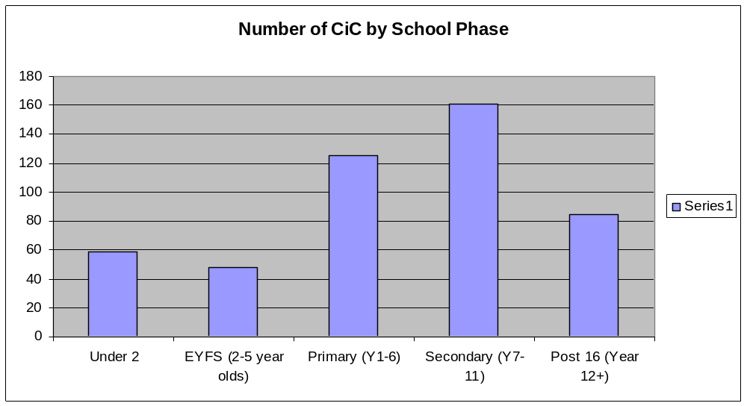

B&H is corporate parent to 478 children and young people in care, 286 of whom are statutory school age.

Children in Care by gender and year group

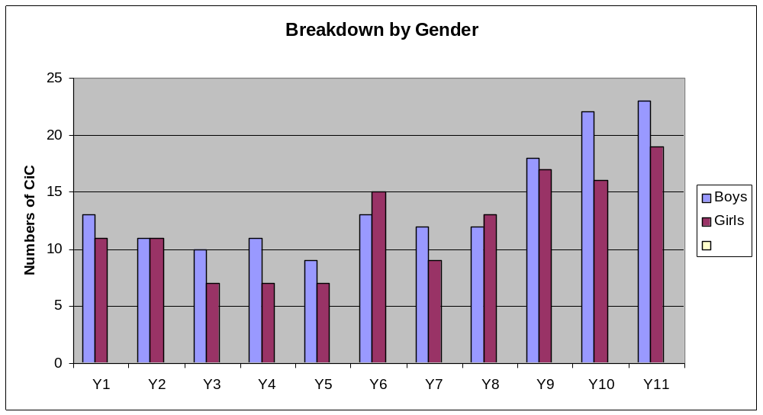

54% of statutory school age CiC are male and 46% female.

Children in Care by Phase and Year Group

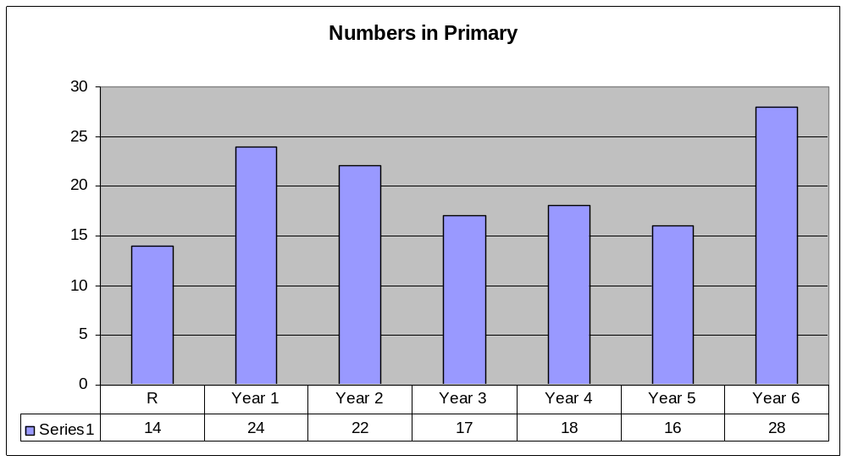

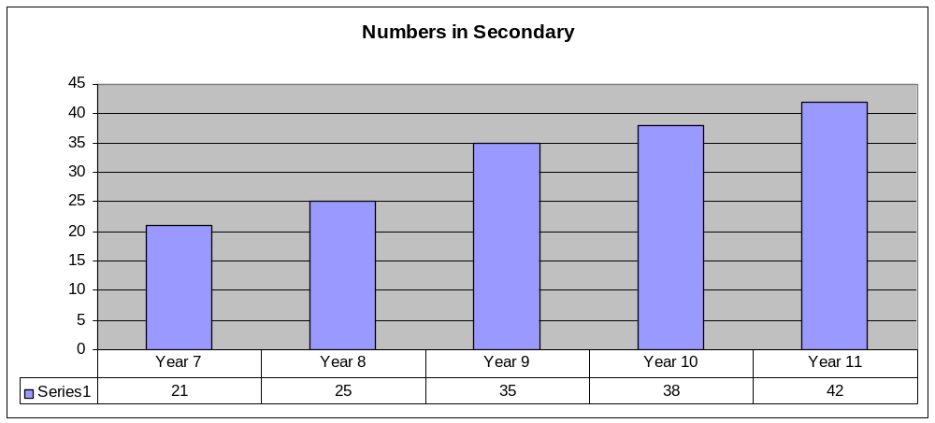

Children in Care by ethnicity

Breakdown by Ethnicity
 | Total | R | Y1 | Y2 | Y3 | Y4 | Y5 | Y6 | Y7 | Y8 | Y9 | Y10 | Y11
White British | 251 | 10 | 23 | 16 | 14 | 17 | 16 | 24 | 17 | 19 | 30 | 24 | 41
White Other | 8 | 1 | 1 |  |  |  |  | 1 |  | 2 | 1 | 1 | 1
White & Black Caribbean | 8 | 2 |  | 2 |  |  |  |  | 1 |  | 1 | 2
White & Black African | 7 | 1 |  | 1 | 1 |  |  |  |  | 1 |  | 2 | 1
White & Asian | 8 |  |  | 1 |  |  |  | 2 |  | 1 |  | 3 | 1
Black / Black British Caribbean | 1 |  |  |  |  |  |  |  | 1
Black / Black British African | 3 |  |  |  |  |  |  |  |  | 1 | 1 |  | 1
Asian / Asian British Bangladeshi | 4 |  |  |  |  |  |  |  |  |  | 1 | 3
Any Other Black Background | 3 |  |  |  |  | 1 |  | 1 |  |  | 1
Any Other Asian Background | 2 |  |  |  | 1 |  |  |  |  |  |  | 1
Other Ethnic Group | 1 |  |  |  | 1
Traveller or Irish Heritage | 1 |  |  |  |  |  |  |  | 1
Mixed other | 6 |  |  | 2 |  |  |  |  | 1 | 1 |  | 2

89% of CiC in Brighton & Hove are from a White British background with 11% BME. The BME population of Brighton & Hove in 2007 was 16% so White British children are over-represented in the CiC cohort as compared to the overall population of the city.

Children in Care by schools – in Brighton and Hove and Out of Authority

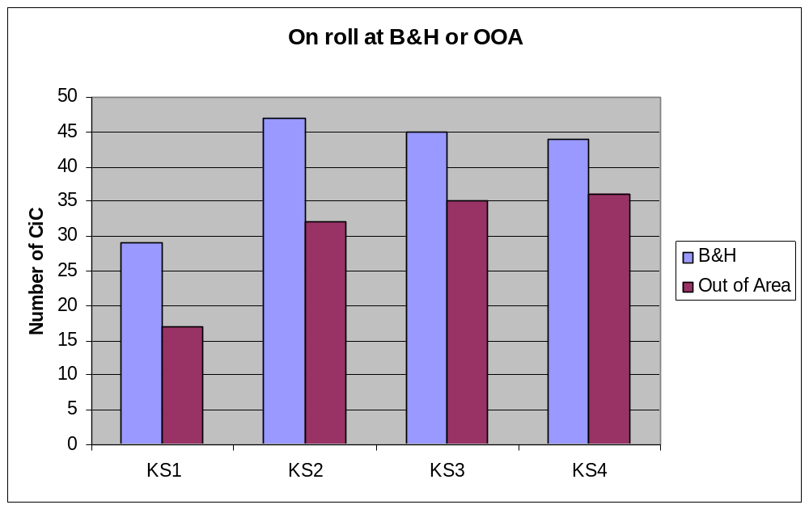

There are 285 statutory school age CiC on roll of the Virtual School. 58% of CiC are on roll at schools within Brighton & Hove.

Special Educational Needs

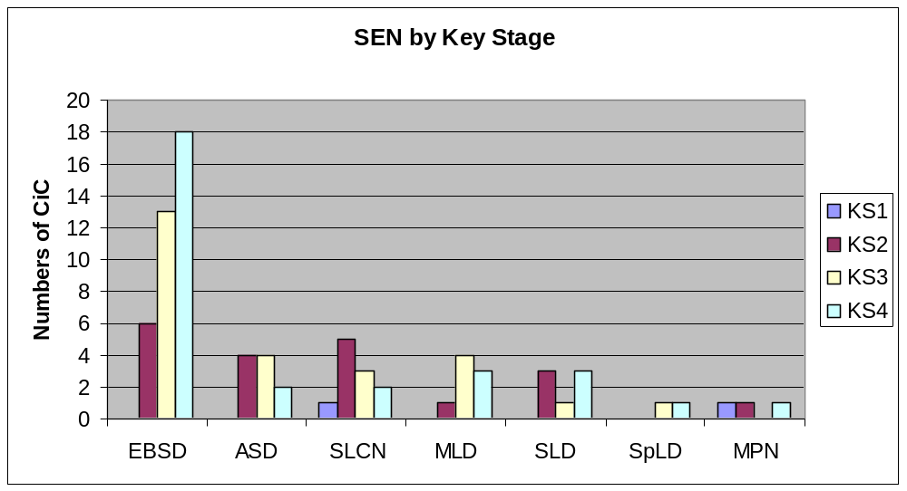

81 chldren and young people (28%) have statements of Special Educational Needs. Of these 46% are for EBSD, which is higher in prevalence ascending through the key stages.

Educational Outcomes – attainment and progress.

Early Years Foundation Stage.

Data

Cohort (end of Reception July 2012)
10 children
4 boys
6 girls

SEN
1 Statement
2 SA+
1 SA

This is the first year that these measures have been used and they are all teacher assessments so the validity cannot be assured.
The importance of the EYFS framework is that it measures Prime Learning Goals, Specific Learning Goals and Areas of Learning to arrive at an overall measure for the holistic development of the child. There is a level of achievement named ‘Good Level of Development’ which is the standard expected of children of this age.
In Brighton and Hove 44.8% of children achieved a Good Level of Development.
No Children in Care achieved this standard and 4 (40%) were in the bottom 20% of children in the city (2 of these have SEN)

Current Practice

- There is an expectation that any child entering care will have a PEP in place once they are eligible for nursery/ pre-school/ reception settings (2-5 years) This is the responsibility of the social worker to set up as part of the Care Planning process.

- An Early Years Designated Person’s forum meets each term and is led by the Senior Educational Psychologist from the Virtual School team.

- The current Carefirst PEP template is not fit for purpose for completion of EYFS PEPs for this age group.

Future development

- Complete and launch the EYFS PEP on Carefirst in the Autumn Term with additional guidance and support to social workers in its use.
- Monitor and quality assure EYFS PEPs once they are available on Carefirst in order ensure timely, high quality EYFS PEPs are in place for all Children in Care within one month of coming into care.
- Establish a more robust and coherent tracking system to ensure that attainment and progress for this age group is recorded and monitored in line with EYFS framework.
- To develop and access interventions for children who are not on track to reach age related expectations.

Best practice example

Brighton & Hove has a team of Early Years Consultants who support the EYFS PEP process. Where there is not a qualified teacher at an early years setting, social workers liaise with the EYFS consultants who will attend and advise at the PEP. Where children are at school nursery settings, the social worker liaises with the designated teacher who will attend the PEP. The Education Provider, the Foster Carer(s), Parent(s), the child’s Social Worker and any other relevant professional are also invited - e.g. Speech & Language Therapist, Educational Psychologist, PRESENS.

Key Stage 1

Data

Cohort
15 children
9 girls
6 boys
7 attend Brighton and Hove schools and 8 attend out of authority

SEN
1 Statemented = 7%
5 School Action+
1 School Action
7 of the cohort have SEN = 47%

Numbers achieving Level 2+ in Reading, Writing and Maths in 2012 and 2013

2012 |  |  |  | 2013
Result | CiC % | All B&H | Nat CiC | Result | CiC % | All B&H
2+ Reading | 50 | 86 | 67 | 2+ Reading | 73 | 90
2+ Writing | 36 | 81 | 57 | 2+ Writing | 73 | 86
2+ Maths | 64 | 92 | 71 | 2+ Maths | 67 | 93

Current Practice
- At KS1 our CiC have achieved at higher than last year’s cohort of CiC nationally for Reading and Writing and slightly below for Maths. In 2013 we have narrowed the gap with the whole population in all three subjects.

- Of the 15 children in the cohort, 13 were entered for KS1 teacher assessments; one was disapplied and one was not attending school due to recently having moved to an adoptive placement.

- Of the children entered for the assessments, 6 attend Brighton & Hove schools and 7 out of area. In B&H 100% of CiC entered achieved level 2+ in Reading and in Writing and 83% achieved level 2+ in Maths. In out of area schools of those entered for the assessments 71% achieved Level 2+ in all three subjects.

Future development
- Ensure that children in Reception and Year 1 who are not on track get access to evidence based interventions such as ECAR and ECC
- Ensure that social care staff understand progress data and request it at all PEPs
- Ensure PEPs are timely and of high quality through the monitoring and quality assurance mechanisms already in place.

Best practice example

Charlie has had a difficult time in the last year with a prospective adoptive placement breaking down at the last minute and she is now being offered permanence with her current carer, where she has been placed since becoming looked after nearly four years ago. Charlie has been feeling anxious since the adoptive placement breakdown, displaying emotional vulnerability and attachment difficulties in her Brighton and Hove infant school. School have used their Pupil Premium money to support Charlie with input from the Learning Mentor which she really enjoys and access to a social skills group. This is additional input that the school would not have been able to fund themselves. The Designated Teacher for Looked After Children has built a warm and trusting relationship with Charlie and school staff have worked hard to offer her reassurance and encouragement. Charlie has an excellent transition plan to support her moving to the Junior school in September and will continue to have social skills group and Learning Mentor support in Year 3. Charlie has done remarkably well academically, in view of the unsettled year she has had and the difficulties she has had to overcome. Charlie’s end of KS1 targets were 2B for Reading, 2C for Writing and 2C for Maths. She achieved 2A 2C 2B so has exceeded her targets for Reading and Maths by a sub-level.

Key Stage 2

Data
These results are for children who have been in care for 12 months or more as of 31st March 2012.
This forms the cohort reported on to the DFE.

Cohort
25 children
15 girls
10 boys
12 attend Brighton & Hove schools and 13 attend out of authority

SEN
6 Statemented = 24%
8 School Action+
6 School Action
20 of the cohort have SEN = 80%

Numbers achieving Level 4+ in Reading, Writing and Maths in 2013, and those achieving Level 4+ in English and Maths in 2012

2012 |  |  |  | 2013
Result | CiC % | All B&H | Nat CiC | Result | No of CiC | % | All B&H
4+ E & M | 40 | 79 | 50 | 4+ RWM | 10 | 40 | 78
4+ English | 53 | 81 | 60 | 4+ Reading | 17 | 68 | 88
 |  |  |  | 4+ Writing | 12 | 48 | 84
4+ Maths | 47 | 82 | 56 | 4+ Maths | 13 | 52 | 87

The percentage of children in Brighton & Hove schools achieving Level 4+ in Reading, Writing and Maths was 50%, compared to 31% in out of authority schools.

% of CiC making 2 Levels of Progress between KS1 and KS2

2012 |  |  |  |  | 2013
Subject | 2 lev | <2 lev | >2 lev | n/a unknown | Subject | 2 lev | <2 lev | >2 lev | n/a unknown
E & M | 55 | 45 | 28 | 36 | RWM | 75 | 25 | 10 | 20
English | 82 | 18 | 28 | 36 | Reading | 95 | 5 | 55 | 20
 |  |  |  |  | Writing | 81 | 19 | 14 | 19
Maths | 64 | 36 | 36 | 36 | Maths | 86 | 14 | 23 | 14

The provisional data for all B&H children making 2 levels of progress or more in 2013 is 90% for Reading, 92% for Writing and 88% for Maths, so our CiC have achieved at higher than the overall authority rate for Reading, significantly below for Writing and slightly below for Maths. In Reading a large number of CiC have made 3 levels of progress or more between KS1 and KS2. In B&H schools we have full sets of data for all 12 children and 9 of these (75%) achieved 3 or more levels of progress. Comparison to the 2012 rates show a considerable narrowing of the gap, but SEN levels were even higher in last year’s cohort (80% were identified as having SEN, with 40% Statemented).

Current Practice
- All children who are not making progress in line with expectations are offered additional interventions on a case by case basis through the PEP process. This may be provided by the school they attend or by the Virtual School depending on availability and suitability. These interventions are agreed through the PEP process which also acts as the trigger for release of Pupil Premium
- This year Pupil Premium money has been used to run a transition programme in partnership with the Music Service for year 6 children moving to 2 secondary schools within the authority. This will be followed up in September and October and could become the model for further projects next year.
- All year 3 and 5 children received Letterbox parcels from May to October.

Future Development
- Develop a specific focus on Writing at KS2 in order to improve attainment in this area.
- Improve the tracking and monitoring of progress against expected outcomes through the use of Welfare Call in order to pick up difficulties more quickly and to put in timely interventions.
- Ensure that social care staff understand progress data and request it at all PEPs
- Ensure PEPs are timely and of high quality through the monitoring and quality assurance mechanisms already in place.

Best practice example
Alan
Alan is in Yr 6. He is looking towards making a positive transition from primary to secondary even though he has been a challenging young person for a number of years. When he came into care 3 years ago he could not read or write and had significant social and emotional difficulties. Through close working between the carers and the school, managed, advised and supported by the Virtual School through the PEP process, he has made incredible progress to this point where mainstream transition is planned, something that was previously unimaginable. The Virtual School has funded additional tuition for 3 years to back up what the school is leading on, and also to allow him the calmness of the 1:1 at home to consolidate his learning and help the carers in their support of him. Alan arrived at the school with no friends but through good partnership working he has now some long lasting friendships. He was at Level 1 when he came into care but achieved a Level 4 in Reading and a Level 3 in Maths in his recent SATs. Through regular PEP meetings the transition planning is already under way with visits, group activities and teacher introductions all part of the ongoing planning.

Key Stage 3
Data
KS 3 Results for CiC 2013
These results are based on the whole cohort – irrespective of their length in care. It should be noted that they have low validity due to the fact that there is no national KS assessment test so these results are all based on teacher assessment. Schools differ in the way they assess – most use National Curriculum levels but increasingly they are moving towards GCSE grades in line with the RAISE online data.

Cohort
38 children
19 girls
19 boys
15 in Brighton and Hove and 23 out of authority

SEN
13 statemented = 34%
3 SA+
4 SA
20 of the cohort have SEN = 53 %

Numbers and % achieving Level 5 and Level 6 in English and Maths

Level | Number of Children | % of cohort
English Level 5 | 12 | 31
English Level 6 or higher | 6 | 16
Maths Level 5 | 8 | 21
Maths Level 6 or higher | 7 | 18
No data | 9 | 24

% of children 2 levels of progress between KS2 and KS3

Subject | 2 lev | < 2 lev | >2 lev | Approx LA fig for 2+ lev
English | 18 | 45 | 0 | 58
Maths | 21 | 42 | 8 | 64
Incomplete or no data | 29 – this is clearly significant

Current Practice

- The high proportion of children for whom the data is incomplete can be explained in part by the number of out of area placements, the fact that they may have come into care recently or had numerous school moves since KS 2. However, it is also indicative of the fact that data collection in the Virtual School is inconsistent and needs to be reviewed.

- The low attainment of this cohort is partially explained by the high percentage of SEN but linked with the poor progress also indicates a need for focussed interventions in KS4.

Future Development
- Improve the tracking and monitoring of progress against expected outcomes through the use of Welfare Call in order to pick up difficulties more quickly and to put in timely interventions.
- Ensure that social care staff understand progress data and request it at all PEPs
- Ensure PEPs are timely and of high quality through the monitoring and quality assurance mechanisms already in place.

Best practice example
Susie
Susie is in Yr 9. She came into care at the beginning of Yr 8 acting chaotically. Her school said that they couldn’t manage her in school or guarantee her safety and really needed her educated elsewhere and probably a special school. Through the PEP process we drew up a structured plan of support, used our links with the EP service to get greater EP involvement and, with good communication between carer and school, returned her to a more engaged and positive working relationship with the school.
She briefly returned home but came back into care, once again in a chaotic state. School were unable to manage her so the Virtual School worked in partnership through the PEP process and again bringing the EP on board to advise. We funded morning sessions at a Foster Care education provision so that she was able to work in a smaller, calmer and more contained setting to re-establish some positive relationships and success in learning. The Virtual School then funded TA support to go into school to support her for afternoon sessions to aid her reintegration into the mainstream setting.
Although Susie made great progress she was still not happy with the school setting due to the unsettling peer group relationships and the proximity of her parents so the Virtual School initiated a transfer to a school close to the foster placement to give her a fresh start and to develop relationships with peers outside of school. This move occurred during the second half of the autumn term and Susie has recently had a very positive PEP where the school described her as ‘an enthusiastic pupil, happy to come to school each day, she has very positive relationships with staff and puts a lot of effort into her work and likes to succeed.’
She is now really enjoying school as reflected by her 99% attendance, has developed some friendships and is looking forward to her KS4 options with genuine enthusiasm.

Key Stage 4
Data

Of the 44 Year 11 pupils in the Virtual School at the end of the academic year, 35 will be formally reported on to the DfE with regard to their GCSE or equivalent results. These children have been in the care of Brighton and Hove continuously for a year on the 31st March 2013.

11 students (31%) within the cohort of 35 have a statement of special educational needs. This compares with just 3% nationally for all children and 21% for children in care (2012). Of these 11 students, 10 were educated in special school provision.

In Brighton & Hove 5 pupils achieved five A*- C GCSEs including English and Maths – this equates to 14.2%. This is currently a significant increase on last year’s validated figure of 6% and is slightly below the national average of 14.6 (2012). This year’s data cannot be validated until Jan 14. We expect an improvement on the figure reported above as we have a significant number of students (10) who have achieved a D in English. We will be requesting remarks for those who are close to the borderline.

In terms of the overall number of GCSEs (or equivalent) achieved in all subjects, grade C and above there is a significant upward trend over the past three years:

2013 – 35 pupils achieved 101 GCSE passes, grade C and above (data not validated)
2012 - 34 pupils achieved 77 GCSE passes, grade C and above
2011 - 26 pupils achieved 57 GCSE passes, grade C and above
2010 - 36 pupils achieved 27 GCSE passes, grade C and above

Of the 35 students 10 (28.6% of the cohort) achieved 5A* - C at GCSE. This is currently below the national average of 36.8% (2012)

Of the 35 students 23 (65.7% of the cohort) achieved 5 A* - G at GCSE. This is currently higher than the national average of 51% (2012)

Of the 35 students, 31 (88.6 % of the cohort) achieved 1 A* - G at GCSE. This is currently higher than the national average of 73% (2012)

Progress from KS 2
Of the 35 students:

11 (31.4%) achieved expected progress or more in relation to their KS2 result in English. This is slightly higher than the national average of 30.3% (2012)

12 (34.2%) achieved expected progress or more in relation to their KS2 result in Maths. This is slightly higher than the national average of 31.0% (2012)

There were 5 students who were performing below level 1 at the end of KS2. We do not have their teacher assessments so their progress will not be reported. However, it should be noted that of these 5;
3 achieved a GCSE E or above in English
2 achieved a GCSE E or above in Maths.
This is significant progress for these young people.

Current Practice
- All students in KS4 are offered 2 hours 1:1 tuition as a matter of course. This may be increased through the PEP process using Pupil Premium if required.

Future development
- Improve the tracking and monitoring of progress against expected outcomes through the use of Welfare Call in order to pick up difficulties more quickly and to put in timely interventions.
- Ensure that social care staff understand progress data and request it at all PEPs
- Ensure PEPs are timely and of high quality through the monitoring and quality assurance mechanisms already in place.
- Prioritise visits to secondary schools in order to raise the profile of Children in Care at a strategic level.
- Pick up any Year 10 student who did not achieve as well as expected at Key Stage 3 in order to offer early help in Key Stage 4
- Ensure that all students in Key Stage 4 have access to IAG either through their own school or through our own 16+ worker.

Best practice example
Alison
GCSE results
Maths – C English Language – A
English Literature – B Science BTec – AA
Geography – C ICT – B
Life Skills – A Sociology – C
Sport Certificate – AA

This is a fantastic achievement in itself but particularly so as Alison has had a chequered education. She transferred from one secondary to another in Year 9 and at this point her levels of attainment were English – 4, Science – 4 and Maths – none recorded.

Following very disruptive behaviour the school wanted to permanently exclude Alison but it was agreed that she would have a fixed term exclusion and then be placed at the PRU on a morning timetable with a late afternoon timetable back at school. She was also at one point placed in Selsey so had to make her way to school from there. This involved getting up at around 5am!

Alison did well at the PRU and was re-integrated successfully back to her mainstream school. During Year 10, she started receiving 1:1 tuition funded by the Virtual School. This was ongoing until the end of the GCSEs. Alison was predicted a C grade in her English but has excelled in this subject, achieving an A.
With support from school, her mum, carer and tutor, Alison became increasingly settled at school. At a PEP meeting during Year 10, she announced that she wanted to get A grades in her GCSEs. At this point Alison was predicted mostly D grades. She also stated that she wanted to be a Lead Student. However it was noted that to do this, she needed to improve her attendance (at that point this was 73%). Alison rose to this challenge and attendance did improve (91% in Year 11).

Alison was also encouraged to attend the school Geography field trip and after school clubs. School agreed to fund this trip which Alison went on and which gave her the opportunity to catch up on all the geography she had missed.

Alison was accepted to attend a UCAS programme in the summer. This was for three weeks and involved an activity week and a week in halls on campus. This was funded using the Pupil Premium.
Alison has now gone on to study A Levels at a local sixth form college.

Key Stage 5
Data
The Virtual School has not had a remit to work with or track Key Stage 5 until this year so we do not hold data about them. However, through liaison with the YES service the following information has been gathered about the current circumstances for the young care leavers who were in Years 12 and 13 in the academic year 2012-13
This data is not entirely reliable as it was gathered before effective information processes had been put in place to ensure that the YES data base was up to date in its recording of care status.

 | Yr 12 | Yr 13
Cohort | 28 young people  14 boys  14 girls | 53 young people  32 boys  21 girls
SEN | 5 with Statements | Data incomplete

Current Situation | Number and % Yr12 | Number and % Yr 13
Sixth Form/ Sixth Form College | 8 = 28.5% | 13 =24.5%
FE College | 9 = 32.1% | 10 = 18.8%
Apprenticeship | 1 = 3.5% | 2 = 3.7%
Work Based Learning /Foundation Learning | 2 = 7.1% | 6 = 11.3%
NEET- including illness/ pregnancy | 8 = 28.5% | 17 = 32%
Other – including moved out of area /custody |  | 5 = 9.4%

Current Practice
- From September 2012- April 2013 a project was run to develop, trial and launch a post 16 PEP. This was a multi- agency project which took an innovative approach. The POP ( Personal Opportunity Plan) is made up of three elements – a supporting book, a quality conversation and an action plan. It centres round the young person and the responsibility for making sure it is completed and acted on is with the social worker although they may not be the person who actually carries out the conversation. The POP has been shared with the National Care Leavers Benchmarking Forum where it received much praise. It will also be the focus of a workshop at the forthcoming Annual Conference on National Care Leavers.
- The development of the role of 16+ IAG advisor in the Virtual School team has been another example of good partnership working with YES. This will enable both teams to have a better tracking and monitoring mechanisms in place for Care Leavers in line with RPA
- Designated People from the major Post 16 providers in the City attend the secondary DP forum.

Future Development
- Evaluate the POP in terms of timely completion, quality of Action Planning, completion of actions and qualitative feedback from Care Leavers and other professionals.
- Ensure that the transition from Key Stage 4 to Key Stage 5 highlights students who are especially vulnerable or who have significantly under achieved in order to prioritise these young people.
- Establish robust and reliable tracking and monitoring for 16, 17 and 18 year old Care Leavers in order to improve outcomes at 19 and beyond.
- Continue to work proactively with the Designated Persons from the major post 16 providers across Sussex in order to get the best possible support for Care Leavers.
- Continue to promote Higher Education to Care Leavers and to be aspirational for them.
Best practice example

Since coming into post in April 2013 the YES worker in the Virtual School has set up and delivered a community based project engaging NEET young people (including care leavers) in work experience renovating a local Boxing Club. This was done in conjunction with the main building contractor for the council and the plan is to extend the project as a method of helping young people to become more work ready and potentially leading to an apprenticeship or employment.

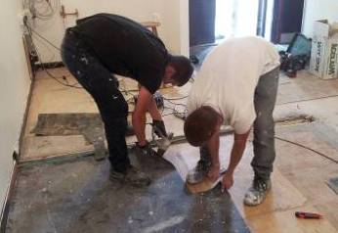

Best practice example
POP case study
A young woman who arrived from Iraq 3 years ago seeking asylum aspires to attend University in the UK. She is a Refugee aged 20 and upon arrival in the UK spoke no English. Education in her home country was limited.

She has been studying ESOL in the UK for 3 years and about to do her Level 1 exams. The college are concerned that she does not fully understand the routes to University in the UK and that she may have unrealistic expectations.

The first POP was the done at college with both her Personal Advisor (from Children’s Services) and tutor present. At this meeting we mapped out her routes to University and set clear goals should she pass her Level 1 exams (the “who, what and when”).

The feedback from this young woman was that she was very thankful that we had taken the time to focus on her education and aspirations.

We mapped out a route to University: 1) level 1 certificates, 2) additional language skills courses and possible GCSE maths 3) a pre-access course, 3) access course 4) improve English language skills through additional part time courses, work or volunteering 5) application to University.

The POP was reviewed prior to the beginning of the next academic year; she needed to re-do components of her Level 1 course. At the point she felt disheartened “I’ll never go to University in this country”. Here we used the page telling the story of various “care leavers” routes to University which settled this young woman as we spoke about how some people can take longer to get to University than others “life is hard”.

Attendance
Data

This graph indicates that overall attendance over time has improved. As may be expected the greatest proportion of absence and persistent absence occurs in KS 4.The data for 2012-13 is not yet available.


The absence rate of Children in Care in Brighton and Hove is in line with its statistical neighbours and the English overall absence rate.

Current Practice
- Our current practice in terms of having up to date, accurate information as regards attendance is inconsistent. There are good internal mechanisms in place for children in school within the authority but for children placed outside we do not have a completely reliable way of monitoring attendance.

Future Development
- Complete a successful Value for Money Bid in order to trial the use of Welfare Call to track and report the attendance of all children in care of statutory school age.
- Liaise with West Sussex and other relevant authorities regarding the best way to use the data provided by Welfare Call in order to set up efficient, effective processes.
- Work with the Behaviour and Attendance Partnership in order to ensure that any attendance issues for Children in Care are addressed with urgency.
- Work with Fostering and Agency Placements to find every opportunity to emphasise the importance of good attendance to carers.

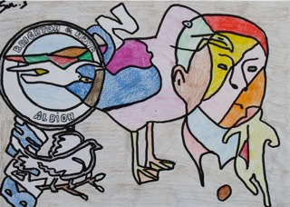

Exclusions
Data

After a significant improvement in 2010/11 there was a slight increase in exclusions in 2011/12. The data for 2012/13 is not yet available. Over time the greatest proportion of exclusions has been in years 9 and 10.


This is the most up to date information available from DfE which indicates that Brighton and Hove CiC have fewer exclusions than most of their statistical neighbours and than the English Average

Current Practice
- The Head Teacher will challenge any school that intends to permanently exclude a Child in Care using statutory guidance to emphasise the importance of finding alternative solutions.
- The Virtual School works proactively with schools and social care colleagues to convene and attend Emergency PEPs where a Child in Care is receiving multiple exclusions in order to problem solve and come up with effective bespoke packages to support the child and the school to improve things.

Future Development.
- Complete a successful Value for Money Bid in order to trial the use of Welfare Call to track and report the exclusion of all Children in Care of statutory school age.
- Liaise with West Sussex and other relevant authorities regarding the best way to use the data provided by Welfare Call in order to set up efficient, effective processes.
- Work with the Behaviour and Attendance Partnership in order to ensure that any exclusion issues relating to Children in Care are addressed with urgency.

Best practice example

Paula came into care in Year 9. Her school, working with her carer, social care and The Virtual School managed her difficult behaviour but she had a number of exclusions and towards the end of Year 10 it became clear that they would not be able to continue to support her in a large mainstream secondary for Year 11. It is very difficult for children to change schools at this point so some creative thinking was required.
After some investigation, and including Paula in all the discussions, a course was found at a local college which was specifically designed for 14-16 year olds and suited Paula’s needs and interests.
This had funding implications but these were addressed through good partnership working; the AWPU from the school at which she was on roll, the Pupil Premium from the Virtual School and additional local authority funding for Children in Care allocated to schools were pooled to fund the place.
Paula is looking forward to starting her course and there are already plans in place for an early PEP to consider her Post 16 options.

Pupil Premium

Data

Pupil Premium 2012-13
Total allocation : £191,884. ( 308 eligible children x £623)

 | Mainstream  (including academies) | Non – mainstream | Total | Number of children
Brighton and Hove schools | £54725 | £4,640 | £59,365 | 133
Out of Area schools | £95,301 | £8,407 | £103,708 | 117
Projects | £4200 | £24,840 | £29,040
 |  |  | 192113
 |  | Overspend | 229

Use of Pupil Premium in Brighton and Hove | Cost | Number of Children
1:1 tuition | £36,285 | 63
Equipment | £12,670 | 33
Extra Curricular Activities | £10,792 | 36

The impact on attainment is evident in the previous sections for each Key Stage.

For 2013-14 the Pupil Premium allocation is £900 for children who have been looked after continuously for more than 6 months. For Brighton and Hove this gives a grant of £277,200 ( 308 eligible children)
In April 2013 there were 317 children of statutory school age in the care of the authority and an additional 48 who are 2 to 4 year olds and should be accessing nursery education and 44 young people of 17 who will be required to remain in education and training as part of Raising of the Participation Age. These children and young people do not attract any additional funding.

Current Practice

- There is a local agreement in place which means that Pupil Premium for Children in Care is held by the Virtual School.
- For all Brighton and Hove schools the Pupil Premium money is accessed through the PEP process which identifies the need for expenditure on a case by case basis. This enables the Virtual School to put money where it is most needed. This is often when children are first in care. (Under the funding formula they would not be eligible for Pupil Premium at this point)
- Allocation of funds for 2013-14 is tracked on a spreadsheet which identifies reason for funding and expected outcome – this will make it a lot easier to audit expenditure and evidence impact in the future.
- Out of area schools will receive their funding on a termly basis unless they make a case for receiving it otherwise. This is to ensure that the money follows the child. We are also developing ways to require out of area schools to be more accountable for their expenditure by requesting information about how the money will be spent and the intended outcome prior to release of funds.
- In the year 2012-13 we were able to fund a number of projects using Pupil Premium. These included supplying a special school with iPads and speech output software alongside additional Learning Mentor’s time to improve communication and engagement. A second project provided a different special school with extra time to develop a Protective Behaviours programme for its vulnerable young people. This is about to be mainstreamed from next year. In a third project we funded the Music Service to develop and deliver a transition project for children in Year 6 to attend their new secondary schools to make music during the summer term at the same time as meeting key people form the secondary staff and some year 7 students who will act as mentors in September.

Future Development.
- Use data to identify trends in terms of achievement gaps in order to commission specific projects aimed at closing them based on evidence based practice.
- In the light of an internal audit of Pupil Premium the Virtual School will act on the recommendation that it provides information about its use of Pupil Premium on the Virtual School page of the external Council website. This will be included in this annual report showing details of the school’s pupil premium allocation and plans to spend it in the current year; and, for the previous year, a statement of how the money was spent and the impact that it had on educational attainment of those pupils at the school in respect of whom grant funding was allocated.
- This report will be flagged up to all head teachers in line with DFE requirements. Head teachers can also use the following statement in their own reports about the spending of Pupil Premium:

‘ In Brighton and Hove headteachers have agreed for the Pupil Premium for Looked After Children to be managed by the Virtual Headteacher to ensure the money is spent smartly and in a co-ordinated way with carers being consulted and closely involved. In agreeing to this arrangement headteachers recognise their corporate parental responsibility for all children in care. The Virtual Headteacher publishes an annual report on the use of Looked After Children’s Pupil Premium and this is available on request and on the website.’

- Continue to allocate Pupil Premium based on individual need as far as possible.

Partnership Working
Current practice
- PEPs
Co -location and the introduction of the Carefirst PEP have provided an opportunity for Virtual School staff to work more closely to support social care colleagues to complete timely, high quality PEPs. Performance in this area has declined since the introduction of the ePEP and the Virtual School have offered a number of supportive interventions to try and improve practice as well as carrying out regular quality assurance. The drop in numbers of completed PEPs is due to a number of issues which it is hoped will be ironed out over the coming months.

- Designated Persons
There are termly meetings for DPs divided into Early Years, Primary and Secondary ( including post 16). These are reasonably well attended and provide opportunities for information exchange and development of best practice. DPs are invited to suggest agenda items that would be useful to them and in the 2012-13 included attendance by the manager of ACAS, a presentation on changes to adoption procedures and exchange of ideas about effective ways of closing the gap.

- Fostering
The Senior Educational Psychologist has provided a number of training opportunities to foster carers through their training programme. She, and the Primary Mental Health worker, have also offered individual ‘surgery’ slots to carers experiencing difficulties with their children and young people. Although those people who have taken these up have reported that they have been very helpful numbers have been low and this will be under review for next year. The Head Teacher addressed the Fostering Network Conference and ex Care Leaver delivered training about higher education to foster carers at Sussex University. As a team, we are proactively exploring further opportunities for linking in more closely with foster families

- SEN/Agency placement
The Head teacher attends fortnightly meetings with the Head of SEN and the Head of Agency Placements in order to ensure that Value for Money is achieved in terms of the placement of some of the most vulnerable and complex young people in care.

- Links to Inspection Frameworks and reporting
The Head teacher keeps up to date with, and provides information for, the relevant Ofsted Inspection Frameworks including the inspection of local authority arrangements for supporting schools, the school inspection framework and the inspection of services for children in need of help and protection, children looked after and care leavers. She also sits on the quality and standards group for Children in Care and contributes to the newly formed Corporate Parenting Board. This is to ensure that practice across professional areas is linked together to ensure the best educational outcomes for Children in Care and that all agencies are familiar with the work of the Virtual School.

- Student voice
The Virtual School has a number of ways of listening to children and young people. They are asked to contribute to every PEP and we also ask for feedback from the clubs we run. The Head Teacher has attended the 16+ Advisory Board on two occasions in order to get care leavers’ input into developing the POP and has fed back their thoughts about the PEP process to Designated Persons. This is an area for development.

- Universities
We have good working relationships with both our local Universities making the most of what their Widening Participation teams offer. Sussex University provided the venue for the POP launch and for foster carer training. Brighton University are involved in the Resilience Project outlined below and have provided the venue and leadership for the Pan Sussex Care Leavers group.

Future development

- Steering Group
In September the Virtual School Steering Group will meet for the first time. This is a strategic multi- agency group which will work like a Governing Body for the Virtual School – holding it to account for it’s performance and offering support and challenge to the Head Teacher.

- Training offer
The Virtual School is well aware of the importance of further improving the educational knowledge and expertise of fellow professionals including foster carers, schools and social care. With this in mind it is aiming to develop a city wide ‘Training’ offer. This is in inverted commas as the intention is to explore innovative ways of engaging fellow professionals in learning such as by holding a multi- agency conference with workshops, offering shadowing opportunities to allow people to find out more about how schools work and identifying opportunities to input training which is already established.

- Student voice
The Head teacher has committed to attending the Children in Care Council on a regular basis, if they will allow this, in order to gather their thoughts about education and disseminate this back through other channels.

- PEP development
The PEP is the central process though which professionals focus on the education of Children in Care and it is essential that it is carried out as efficiently and effectively as possible. For this reason the Virtual School will continue to support, monitor and hold to account practitioners with the responsibility for completion of PEPs . We will also develop an Early Years PEP for Carefirst to go live before Christmas and to be accompanied with specific training. The head teacher has already had assurance from the Manager of CiC that such training will be mandatory.

Best practice example
The Resilience Project
In partnership with the University of Brighton a number of Children in Care and Care Leavers have been involved in creating a resource about resilience. This is based on the framework developed by Professor Angie Hart and has required the children and young people to take part in intensive interviews about their own experiences and art work shops. From these sessions their ideas are being collated into a resource for use by carers, professionals and young people to help them understand better how to recognise, support and develop resilience. The designer is a care leaver himself who is passionate about supporting others to achieve their aspirations. The resource will hopefully be launched by the young people at the British Adoption and Fostering Conference in London at the end of October and the intention then is for the young people to trained up to deliver training on it themselves.

Additional Activities
Current Practice
- 1:1 tuition
The Virtual School offers 1:1 tuition to all Children in Care in Key Stage 4 . This is accessed through the PEP process and is usually for English and/or Maths as required. We have a group of highly experienced local tutors to deliver this work and use an agency for delivery outside of area. All tutors must provide records to the Virtual School and to the school at which the child is on roll. Additional tuition or tuition to younger people can be offered through Pupil Premium funding.

- Clubs
The Virtual School currently runs the following clubs:
- table tennis
- vocal group
- football
- dance
- athletics

These have enabled our young people gain a real sense of belonging whilst developing individual interests and abilities with peers who are also in care.

A music group that was the first of the Virtual School clubs has performed and received a fantastic response at the last 2 CIC Awards events. With the support of the VS and Rhythmix two members (Year 12) of the Vocal Group will be completing Level 2 Rock School Accreditations linked to their session time and performance at the next CiC awards ceremony.

The Dance Group have also performed at the CIC Award Ceremony and at a Patcham cluster dance show at the Clarendon Centre.

- Awards ceremony
Brighton & Hove holds an annual awards ceremony, usually in November, to recognise the diverse achievement of our Children in Care. Overall responsibility is held on alternate years by the Virtual School and the Fostering and Adoption Team. Last year’s ceremony was run by the VS and took place at the Amex Community Stadium where 52 children and young people received awards for academic success, good attendance, engagement with learning, sport, music, drama and helping others. There were performances from the VS dance and music groups and a guest appearance from local celebrity and youtube sensation Hobbie Stewart. The young people and their guests had a very memorable and enjoyable time. This year’s event, run by Fostering and Adoption will be in the Corn Exchange on the afternoon of 4th November.

- Summer transition activities
Our Primary Mental Health Worker is running a summer transition project for children in years 6 and 7 to provide an opportunity for them to take part in outdoor adventurous activities and receive additional support to address anxieties and worries about moving on to secondary school.

- Virtual School newsletter
The first edition of the Virtual School Newsletter was distributed to schools, carers, social care staff and children this term and will be a termly publication developing in line with the feedback from recipients.
Future Development
- Explore options to extend the range of clubs and extra curricular activities available to Children in Care in line with budget limitations.
- Explore digital media options for information sharing and communication in line with what Children in Care and other professionals tell us they want.
- Continue to find opportunities to celebrate the successes of Children in Care and Care Leavers.
- Continue to find opportunities to involve Children in Care and Care Leavers in service design and training.

Best practice example
Table Tennis Club

The Virtual School runs a weekly table tennis club at a local secondary school. It is attended by 10 young people ranging in age from Yr 5 to Yr 11. Being part of the Table Tennis Club has enabled the young people to have had the opportunity to take part in fundraising activities, holiday fun sessions, and to see the Table Tennis at the London Olympics. There have also been visits from two Olympians who have taken part in Club. Three of the older members of the club have also been given the chance of taking their table tennis further and are taking a Level 1 Table Tennis Coaching Award.

Photo ? 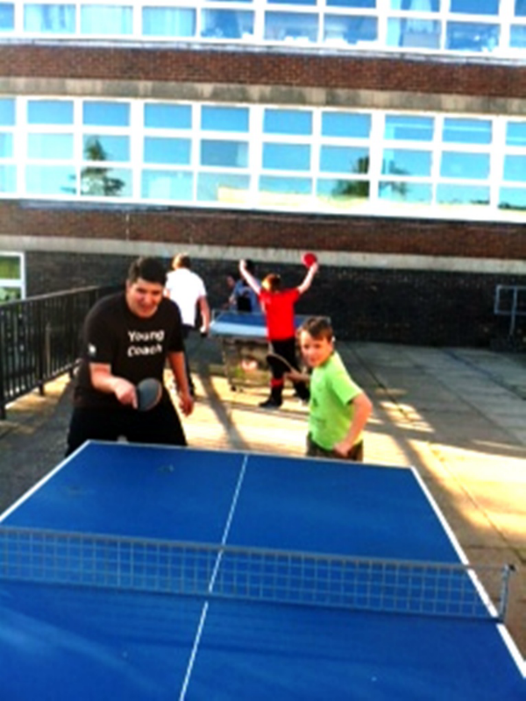

Priorities.
- Create and make better use of a coherent and robust data collection process in order to track progress and intervene in a timely way when it tells us there are gaps appearing for all Children in Care and Care Leavers between the ages of 2 and 18

- Continue to work closely with social care and schools to improve the PEP process to ensure that timely high quality PEPs are in place for all Children in Care and that the actions that come from them are carried out.

- Establish a Steering Group to provide support and challenge to the Head Teacher of the Virtual School.

- Work proactively and directly with Children in Care and Care Leavers to ensure their opinions regarding what can be done to support them to get the best educational outcomes are shared with schools and other agencies



Glossary

ACAS - Advice, Contact and Assessment Service

AWPU – Age Waited Pupil Unit – the funding devolved to schools

CAMHs - Child and Adolescent Mental Health Service

CiC - Children in Care

DfE - Department for Education

DP - Designated Person – a statutory role in schools with special responsibility for Children in Care.

EP - Educational Psychologist

EYFS - Early Years Foundation Stage – the framework for children from 2-5

PEP - Personal Education Plan – a statutory requirement for all Children in Care of school age.
.
POP – Personal Opportunity Plan – the 16+ version of the PEP developed in Brighton and Hove

SEN – Special Educational Needs

SENCO - Special Educational Needs Coordinator – the person in school with responsibility for SEN

YES - Youth Employability Service

