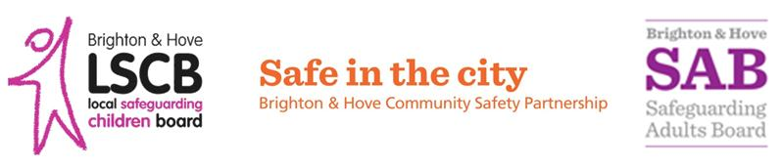

**Learning Together**

**to Safeguard the City**

**Thursday 26th November – Thursday 10th December 2015**

The **Learning Together to Safeguard the City** fortnight is a new way of talking about how we all work together to keep people safe and well. It is delivered in partnership between the Safeguarding Adults Board, the Local Safeguarding Children Board and the Safe in the City Partnership Board, as well as Brighton & Hove City Council, other statutory partners including Sussex Police and Health, and a range of charities and community groups.

[www.brightonandhovelscb.org.uk/learning-together-to-safeguard-the-city](http://www.brightonandhovelscb.org.uk/learning-together-to-safeguard-the-city/)

**#LearningTogether #Safeguarding #EveryonesResponsibility**



**Learning Together**

**to Safeguard the City**

**Thursday 26th November – Thursday 10th December 2015**

The **Learning Together to Safeguard the City** fortnight is a new way of talking about how we all work together to keep people safe and well. It is delivered in partnership between the Safeguarding Adults Board, the Local Safeguarding Children Board and the Safe in the City Partnership Board, as well as Brighton & Hove City Council, other statutory partners including Sussex Police and Health, and a range of charities and community groups.

[www.brightonandhovelscb.org.uk/learning-together-to-safeguard-the-city](http://www.brightonandhovelscb.org.uk/learning-together-to-safeguard-the-city/)

**#LearningTogether #Safeguarding #EveryonesResponsibility**



**Learning Together to Safeguard the City**

We hope you have found this multi agency event informative, and would appreciate if you could take the time to answer a few questions to help assist with the planning of future learning events.

Has this session provided you with **information** that will be useful in your work? **Yes** **No**

One thing that I have **learnt** from this event:

One thing that I will now **do** in my professional practice:

One thing that I **want** my organisation to take forward:

Is there anything else you wanted to see covered during **Learning Together to Safeguard the City** Fortnight?

Name: Job Title:

Organisation:

If you have any further comments please email them to [**LSCB@brighton-hove.gov.uk**](mailto:LSCB@brighton-hove.gov.uk)

**Learning Together to Safeguard the City**

We hope you have found this multi agency event informative, and would appreciate if you could take the time to answer a few questions to help assist with the planning of future learning events.

Has this session provided you with **information** that will be useful in your work? **Yes** **No**

One thing that I have **learnt** from this event:

One thing that I will now **do** in my professional practice:

One thing that I **want** my organisation to take forward:

Is there anything else you wanted to see covered during **Learning Together to Safeguard the City** Fortnight?

Name: Job Title:

Organisation:

If you have any further comments please email them to [**LSCB@brighton-hove.gov.uk**](mailto:LSCB@brighton-hove.gov.uk)

