## Food Hygiene Level 2 - Course Information sheet

Tutor: James Aldcroft

**When:**

**Time:**

**Where**:

This course aims to:

* Help you understand how to control food safety risks (personal hygiene, food storage, cooking and handling) in a food preparation area
* Give you confidence and the skills to prepare, cook and store food safety
* *Refreshment of this qualification is recommended at least every three years*

Who this course is for?

Anyone volunteering or working in catering, or a setting where food is prepared cooked or handled

How will I know how I’m doing on the course?

The tutor will explain what he will be covering on the course at the beginning of the session, and provide opportunities for you to review your learning, and take part in practical demonstrations. There will also be lots of opportunities to ask questions and your learning will be reviewed at the end of the session.

There is a multiple choice assessment at the end of the course.

Do I need to bring anything to the course?

* Pen and pad if you would like to make some notes (handouts from the session are provided)

Are there any other websites or books that can help me?

You can have a look at the Food Standards Agency [www.food.gov.uk](http://www.food.gov.uk)   
or the NHS Choices food safety website [www.nhs.uk/Livewell](http://www.nhs.uk/Livewell) Search for ‘f*ood safety’*

**Can I download any useful apps to my Smartphone or tablet?**   
Here are some QR codes that link you directly to the Food Standards Agency, and a fun quiz to help you learn some the myths around food safety.

This food safety quiz includes some common food safety

myths – find out if you're able to separate fact from fiction

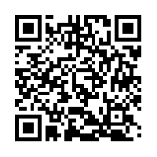

Food Standards Agency website QR Code

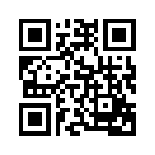

***New to QR codes? Here are some steps to help you download QR code software for your mobile phone or tablet***

1. *Open your mobile app store (App Store, Google Play, Windows Marketplace, etc.)*
2. *Search for QR code readers. ...*
3. *Follow the instructions to download a QR reader to your phone, open it and you are ready to scan!.*

# Who is the tutor?

James Aldcroft has had a long, varied and successful career that reflects perfectly on the successful and innovative business that is Square Lemon. He trained as a teacher, both here and abroad. After his travels, he taught himself to cook and trained as a chef.

What next, after the course?

One you have successfully passed the multiple choice assessment, you will receive a nationally accredited certificate (this may take up to two to three weeks) Please call the centre 01273 810 210

to find out whether your certificate is here and ready to collect.

**You can also speak to our Information, Advice and Guidance (Christina) who can help you with:**

* Impartial guidance to help you make the right choices
* Advice on volunteering and training
* Initial assessment for English and maths

Call Christina Mendez to find out more on:

**01273 810213 / 0779 533 6412**

**Learning across the city**

You can also find online links to all our adult learning partners across the city by visiting:

www.bh-adultlearning.org.uk

Make any handy notes or questions here that you would like to bring to the course.



**

**BHCC Community Learning at the Friends Centre**

Brighton Junction, Isetta Square, 35 New England Street, Brighton, BN1 4GQ | (01273) 810210